**Unit 1: Properties of Functions and Rates of Change**

Practice

1. List the values of for the constants k, d, a and c then graph the function and state the domain and range.
2. $y=-\sqrt{2x-6}-1$ b)

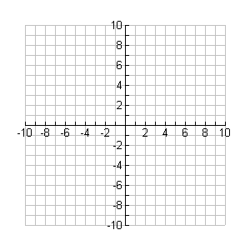

**y**

**x**

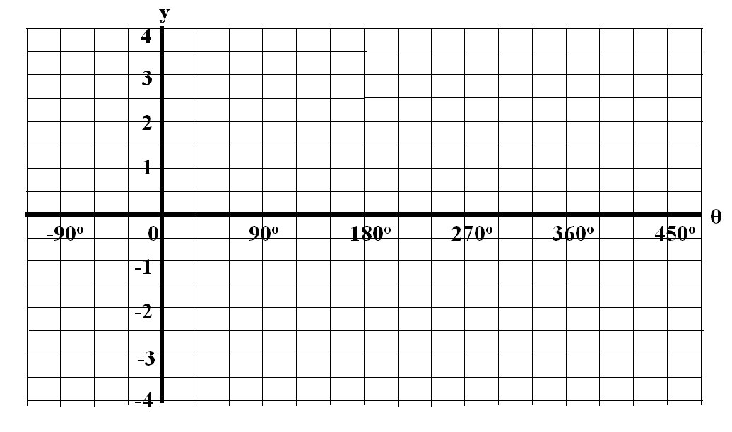

c) $y=-2^{0.5x-1}+6$ d) $y=\frac{3}{-2x+4}-1$



**y**

**x**



**y**

**x**

1. Determine if the following functions are even, odd or neither.

a) y =  b)  c) $y=2cos⁡[θ-{90}^{o}]$

1. An object is thrown in the air such that its height in metres as a function of time in seconds is modeled by:



Determine the rate of change when t = 5 seconds.

1. Determine the inverse of the following functions:

a)  b)  c) 

1. Louis has boarded a Ferris wheel. His height is modeled by the equation:



* where H represents his height in metres and t represents time in seconds.

Determine Louis’ rate of change from 50 seconds to 100 seconds.

1. Create simple functions that satisfies the properties listed below:

a) has an interval of decrease (3, ∞) and interval in increase (- ∞, 3)

b) has a range of 

c) has an interval of decrease of (-∞, ∞) and a range of 

d) has a vertical asymptote at x = 1 and a horizontal asymptote at y = -4

1. Given the functions f(x) and g(x) below, perform the following operations.

 

a) f + g b) fg c) f(g(x)) d) g-1(f(x))

1. State the degree of each resulting function in question 7.
2. For the function , calculate IROCs at and around the point where x = 3 to determine if this point is stationary and then identify its type.
3. Highlight the portions of the numberline represented by each:

a) |x|3



b) |x|5



11. Create an inequality expression using the absolute value function to represent the

following:

a) 

b) 

12. Determine the x and y-intercepts for each function below.

a)  b) 