Hmwk: pg 155 #1, 2aef, 3, 4e, 5, 6f, 9, 10, (13)

**Transformations of Simple Cubic/Quartic Functions**

If a single termed polynomial is chosen as a parent function as follows:

$$f\left(x\right)= x^{n}$$

where

* n is a whole number constant.

Then this function can be transformed to create a new function:

$f(x) = a{\left[k(x - d)\right]}^{n} + c$

where k, d, a, and c represent the usual transformations.

k --> represents a horizontal expansion/compression by a factor of  followed by a

mirror reflection about the y-axis if 'k' is negative.

d --> represents a horizontal shift right if 'd' is positive and left if 'd' is negative.

a --> represents a vertical expansion/compression by a factor of |a| followed by a mirror

reflection about the x-axis if 'a' is negative.

c --> represents a vertical shift up if 'c' is positive and down if 'c' is negative.

These transformations can be applied one by one to create the new function.

Alternatively, the transformations can be done using a mapping statement; see below;

parent function transformed function

(x, y) ----------> 

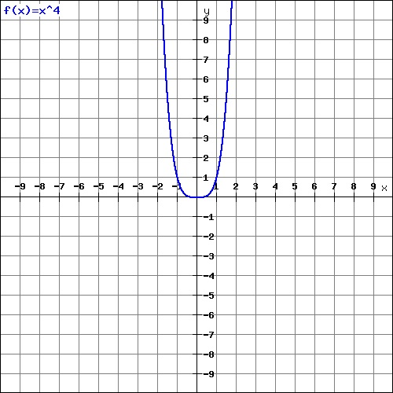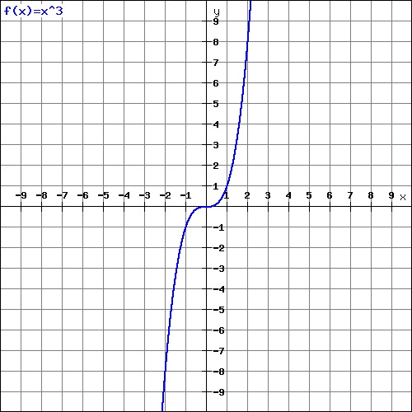The parent functions for the cubic and quartic relations are shown below. $f(x) = x^{3}$ $f(x)=x^{4}$

|  |  |
| --- | --- |
| x | f(x) |
| -1.5 | 5 |
| -1 | 1 |
| 0 | 0 |
| 1 | 1 |
| 1.5 | 5 |

|  |  |
| --- | --- |
| x | f(x) |
| -2 | -8 |
| -1 | -1 |
| 0 | 0 |
| 1 | 1 |
| 2 | 8 |

**Practice**

1. Graph the following functions below using the individual transformations k, d, a, and c or using a mapping statement. State the domain and range.

a) $f(x) = -2{(x- 3)}^{3}+7$ b)

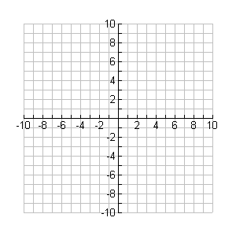

**y**

**x**



**y**

**x**

k = k =

d = d =

a = a =

c = c =

domain: _________ domain: _________

range : _________ range: __________

2. Determine the x-intercepts for each function below.

a) b)

3. Show algebraically why the following two functions would have the same final graph even though one includes a vertical expansion while the other uses a horizontal compression.

Horizontal compression by factor  Vertical expansion by factor 8

f(x) = (2x)3 g(x) = 8x3

*** Since two different transformations result in the same graph, you cannot tell, working back from a graph, the difference between a horizontal expansion/compression from a vertical expansion/compression for basic polynomial functions.***