Homework: pg 457 #1,3,4ac(i, iii, v), 5df, 6, 7, 8, (9)

**Transformations of Logarithmic Functions**

Logarithmic functions are transformed in the same way as other functions:



k --> horizontally expands/compresses by a factor of .

If 'k' is negative then the point is subsequently reflected about the y-axis.

d --> horizontally shifts the points 'd' units to the right.

a --> vertically expands/compresses by a factor of |a|. If 'a' is negative, then the point is subsequently reflected about the x-axis.

c --> vertically shifts the points up 'c' units.

When the base of the logarithmic function is 10, as indicated in the template above, then the following vertical asymptote and two points are used to represent the parent function ready to be transformed:

|  |  |
| --- | --- |
| x |  |
| 0 | Vertical Asymptote |
| 1 | 0 |
| 10 | 1 |

For the vertical asymptote, we will only apply the horizontal shift 'd'.

For a different base, the last entry for ‘x’ would change to this new base.

Example

Graph the following functions and state the domain and range.

a)  b) 

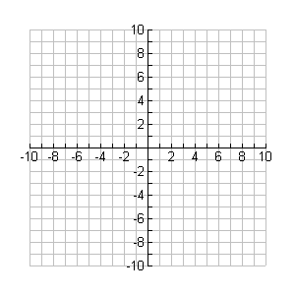

**y**

**x**



**y**

**x**

Domain: ______ Range: ____ Domain: ________ Range: ____

Practice

Graph each function below and state the domain and range.

a)  b) 



**y**

**x**



**y**

**x**

Domain: ______ Range: ____ Domain: ________ Range: ____

c)  d) 



**y**

**x**



**y**

**x**

Domain: ______ Range: ____ Domain: ________ Range: ____

e)  f) $y=3{log⁡}_{2}(-x-5)+1$



**y**

**x**



**y**

**x**

Domain: ______ Range: ____ Domain: ________ Range: ____