Homework: pg 43 # 1ac, 2ac, 3, 6ac, 7, 9, 10abce, (11), 12ab, 14

**Grade 11 Review – Transformation of Functions: Part 2**

Transformations can be applied to sinusoidal functions.

Create sketches of the following functions over the domain $0^{o}≤θ≤{360}^{o}.$

y = sinθ y = - sinθ y = cosθ y = - cosθ

Fill in the blanks and graph the sinusoidals below.

a) y = 2sin(3θ - 90o) – 1 b) y = -3cos(2θ – 120o) + 1

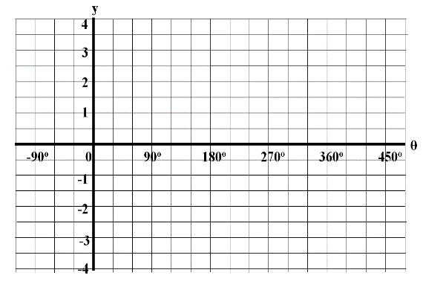k = k =

d = d =

a = a =

c = c =

Domain: Range: Domain: Range:

** **

** **

Create an equation for each sinusoidal below:

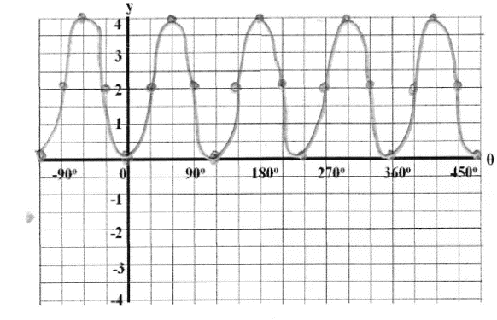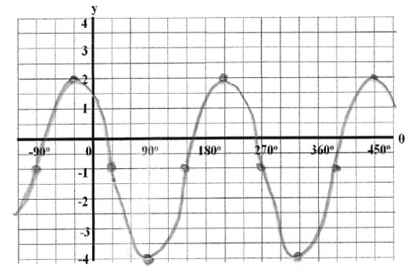a) b)

**Grade 11 Review - Inverse Relations**

The inverse to a function is found depending on the presentation of the relationship.

**Table of Values**

The inverse is found by swapping x and y coordinates.

Example

**Inverse**

|  |  |
| --- | --- |
| **x** | **f(x)** |
| **1** | **-7** |
| **3** | **-3** |
| **6** | **-1** |
| **8** | **3** |

|  |  |
| --- | --- |
| **x** | **f-1(x)** |
|  |  |
|  |  |
|  |  |
|  |  |

**---------->**

**Equations**

Swap the variables then isolate for the new dependent variable (y).

Example

Determine the inverses to each function below.

a) f(x) = 2x - 8 b) f(x) = 3x2 + 12  **c) **

Note: The inverse of a function is not always a function. The notation

f - 1(x) may only be used if the inverse is a function.

**Graphs**

The inverse of a function can be found from a graph by swapping the x and y coordinates of each point. It can also be found by reflecting the graph about the y = x line; this is emulated by placing your right hand at the top of the page, your left hand at the bottom of the page and flipping the page.

Example

Graph the following function and its inverse. Also, state the domain and range.

y = 2(x + 3)2 - 8 The inverse of y = 2(x + 3)2 - 8

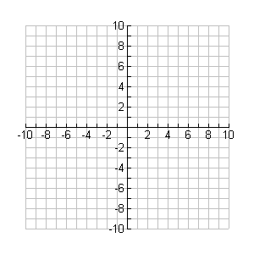

**y**

**x**



**y**

**x**

Domain: Domain:

Range: Range:

Note: The domain of the inverse is the range of the original function.

The range of the inverse is the domain of the original function.

**Application**

In some situations when dealing with an application question, we do not swap variables when finding the inverse.

Example

Find the inverse of the equation and use it to determine the radius of a circle with an area of 100 cm2.