Transformations of Sinusoidals: Part 1

For sinusoidals of the form:

$y = a∙sin⁡[k\left(θ - d\right)] + c$ or $y = a∙cos⁡[k\left(θ- d\right)] + c$

k 🡪 Horizontal compression/expansion; used to determine the period.

d 🡪 Phase (horizontal) shift

a 🡪 Vertical expansion/compression; |a| 🡪 amplitude

c 🡪 Vertical displacement and the location of the line of equilibrium.

The numerical constants (k, d, a, and c) produce the same transformations as they would with all other functions.

# Method 1: The 5-point system

To graph a sinusoidal function:

1. Transform the following 5 points.

|  |  |
| --- | --- |
| θ | $$y=\cos{θ}$$ |
|  | 1 |
|  | 0 |
|  | -1 |
|  | 0 |
|  | 1 |

|  |  |
| --- | --- |
| θ | $$y=\sin{θ}$$ |
|  | 0 |
|  | 1 |
|  | 0 |
|  | -1 |
|  | 0 |

1. Add points beyond the 5 initial points continuing the pattern to the edge of the grid.
2. Draw a smooth curve through the points.

**Method 2: The Box Method**

1. Draw a line of equilibrium determined by the value of ‘c’.
2. Use the phase shift d and amplitude |a| to create the left side of the box.
3. Use the k value to determine the period and use this value to create the width of the box.
4. Fill in the box with points representing one cycle of the sinusoidal.
5. Continue to pattern horizontally across the grid.

Note: In the graphs below, each horizontal space is equivalent to 30o or .

**Example 1**

Graph $y=-2\cos\left(θ+\frac{π}{3}\right)-1$ using the 5 point method. State the domain and range.

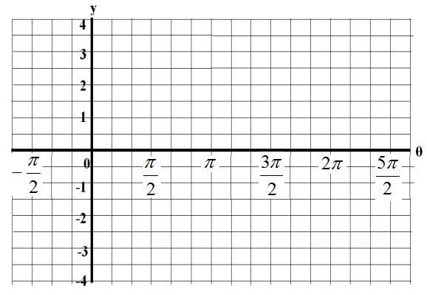

k =

d =

a =

c =

Domain:________ Range: __________

**Example 2**

Graph $y=-3\sin\left(θ-\frac{π}{2}\right)+1$ using the box method. State the domain and range.



k =

d =

a =

c =

Domain:________ Range: __________

Homework: Complete the graphs on the following page + pg 343 #5, 6ac

**Practice**

Use the 5 point method or box method to graph each sinusoidal function below.

**a)  b) **



**c)  d) **

**e)  f) **