**Stationary Points** Hmwk: pg 111 # 1, 2, 5ac, 6adf, 10, 15(only for x2)

Stationary point – a location on the graph where the instantaneous rate of change is equal to ______.

Stationary points play a significant role in mathematics when we are interested in determining the maximum or minimum value of a function; this topic in mathematics is often referred to as ____________ and is discussed in more detail in most introductory Calculus courses.

Three different conditions can occur at a stationary point:

1. _____________ 2. _____________ 3. ________________

**Example 1**

Graph the function  using the table of values provided.

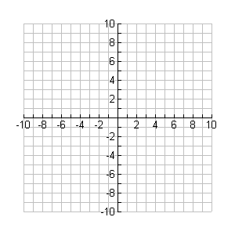

**y**

**x**

|  |  |
| --- | --- |
| **x** | **f(x)** |
| **-3** | **-25** |
| **-2** | **-6** |
| **-1** | **1** |
| **0** | **2** |
| **1** | **3** |
| **2** | **10** |
| **3** | **29** |

Calculate the IROC at and around the function when x = 0 to determine if this location is a stationary point and identify its type (if applicable).

a) x = -1 b) x = 0 c) x = 1

**Example 2**

Graph the function  using the table of values provided.



**y**

**x**

|  |  |
| --- | --- |
| **x** | **f(x)** |
| **-1** | **-19** |
| **0** | **-3** |
| **1** | **1** |
| **2** | **-1** |
| **3** | **-3** |
| **4** | **1** |
| **5** | **17** |

1) Calculate the IROC at and around the function when x = 1 to determine if this location is a stationary point and identify its type (if applicable).

a) x = 0 b) x = 1 c) x = 2

2) Calculate the IROC at and around the function when x = 3 to determine if this location is a stationary point and identify its type (if applicable).

a) x = 2 b) x = 3 c) x = 4

Note:

At a local maximum, the IROC is zero. The IROC is positive to its left and negative to its right.

At a local minimum, the IROC is zero. The IROC is negative to its left and positive to its right.

At a point of inflection, the IROC is zero. The IROC has the same sign to the left and right of the stationary point.