Hmwk: pg 285 #1, 2-7(ace), 9

**Solving Rational Equations**

There are many strategies used to solve rational equations:

1. Cross multiplication
2. Multiplying Through
3. Common Denominator
4. Graphing

Cross Multiplication

If an algebraic equation can easily be reduced to a single fraction on both sides of an equal sign, then cross multiplication can by an optimal technique to use.

Solve the following.

a)  b)  c) 

Multiplying Through

If single fractions cannot easily be made on both sides of a fraction, consider multiplying through by a common denominator.

Solve the following.

a)  b)  c) 

Common Denominator

Sometimes, the denominators of all components in a rational equation are all very similar. In these cases, it may be ideal to use a common denominator.

Solve the following.

a)  b)  c)

Graphing

The graphing method can be an ideal choice for solving a rational equation when a graphing calculator or software is readily available.

Solve the following equation by graphing.



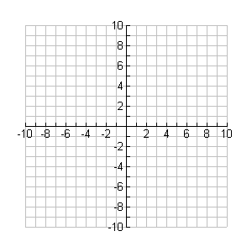

**y**

**x**