Homework: pg 435 #1abc, 2ac, 3, 4-8ace, 9ac, 10, (11), 12, 14, 15a, (18)

**Solving Quadratic Trigonometric Equations**

Prior Knowledge:

There are several methods to solve a quadratic equation:

1. Factoring
2. Quadratic Formula
3. Graphing

A quadratic equation may have two solutions, one solution or no solution.

**Activity 1**

Solve the equation $x^{2}+2x-8=0$ using multiple techniques.

Factoring Quadratic Formula Graphing

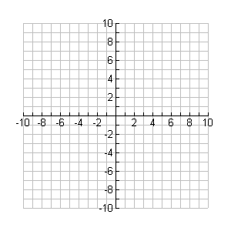

**y**

**x**

**Example 1**

Solve the equation $2\cos^{2}{θ}-1=0$; $0≤θ≤2π$.

**Example 2**

Solve the following trigonometric equations; $0≤θ≤2π$.

a) $3\cos^{2}{θ}-11\cos{θ}=-6$ b) $-2\cos^{2}{θ}-3\sin{θ}+3=0$

**Example 3**

Solve the following trigonometric equations; $0≤θ≤2π$.

Hint: Factoring may help.

a) $\sin{θ}(\cos{θ}-1)=0$ b) $\sec{θ}\csc{θ}-2\csc{θ}=0$

**Example 4**

How would you start a solution to the following equations below?

a) $5\cos{2}θ-\cos{θ}+3=0$ b) $-2\cos{2}θ=2\sin{θ}$ c) $\sin{2θ=\cos{θ}}$