Hmwk: pg 225 #1ac, 2, 3, 5ab, 6ac, 7ace, 8, (10), 12cd, (14), (18)

**Solving Polynomial Inequalities**

Polynomial inequalities can be solved using two methods:

1. Factors/Sign chart (Number Line Strategy)
2. Graphing

Factors Chart/Number Line Strategy

1. Move all terms to one side of the inequality.
2. Factor the polynomial.
3. List the ordered solutions of x along the top of the chart.
4. List the factors down the left.
5. Determine the product of the factors in each column.

Example 1

Solve using a factors chart.

Example 2

Solve  using a factors chart.

Graphing Method

1. Move all terms to one side of the inequality.
2. Factor the polynomial.
3. Use your knowledge of polynomial functions to sketch a graph of the factored expression.
4. Examine the graph to see where the function is positive or negative.

Examine 3

Solve  using the graphing method.

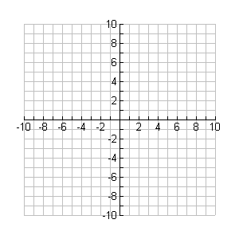

**y**

**x**