Homework: pg 426 #1abc, 2abc, 3, 4, 6ace, 8ab, 10ad, 12, (13), (17)

**Solving Linear Trigonometric Equations**

Recall:

**  **

Example 1

Create a sketch of the function y = sinθ.

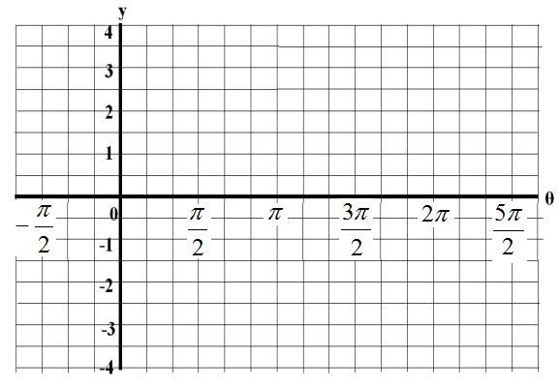

Using the above graph, solve the following equations: .

a)  b)  c) 

Example 2

Use your knowledge of special triangles and the CAST rule to determine the exact solution for each equation below: .

a)  b) 

Example 3

Solve the following trigonometric function;.

a) 

Example 4

Avalon boards a Ferris wheel. Her height, H, as a function of time is defined by:

$$H(t)=-10\cos\left(\frac{π t}{2}\right)+12$$

where 't' is the time in minutes.

If the wheel only makes one turn, how long was Avalon above a height of 16 metres?