Hmwk: pg 213 #1ace, 2ace, 3, 4ace, 7ace, 9b, 10,11ab, 12, 17

**Solving Linear Inequalities**

linear inequality - a pair of algebraic expressions of degree 1 or less surrounding an inequality.

Some of these inequalities include:

 greater than or equal to

 greater than

 less than or equal to

 less than

Solving a linear inequality is done in much the same that a linear equation is solved with the inclusion of one extra rule:

**When both sides of an inequality are multiplied or divided by a negative, the direction of the inequality must be changed.**

**Example 1**

Solve the following linear inequalities.

a) 4x + 4 < 20 b) 2(x + 5) $≤$ 4(x + 4) c) 6x - 1  9x + 14

**Example 2**

Express your answers from Example 1 on a numberline.

a)



b)



c)



Linear inequalities can also be solved by graphing.

**Example 3**

Create graphs for both sides of the inequality to solve for x. Express the answer using the numberline.

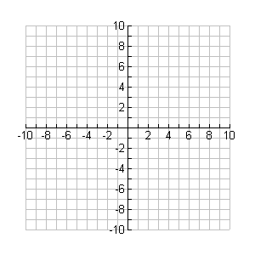

**y**

**x**





Double inequalities are really a combination of two inequalities. They can be solved by determing where the two solutions overlap.

Example 4

Solve the double inequality.

$$30≤3(2x+4)-2(x+1)<46$$

Left Inequality



Right Inequality



Final Solution

