Hmwk: pg 176 #1, 2, 3,4-8(ace), 9, (10), (12), (16)

**The Remainder Theorem**

Review

Divide the following polynomials.

a)  b)  c) 

Consider examples a) and b) above. Suppose we substitute x = 1 in the numerator of a) and x = -3 in the numerator of b). What is the result?

a) f(x) = x3 + 2x2 - 5x + 7 b) f(x) = x3 + 5x2 + 2x - 12

f(1) = f(-3) =

The results are the same as the remainder from the first two examples above.

If we divide any polynomial f(x) by 'x - a', we get the following...



Rearranging, we get...



When we evaluate f(x) at the value x = a, we get...



Remainder Theorem

When a polynomial f(x) is divided by bx - a, the remainder is equal to $f\left(\frac{a}{b}\right)$.

Practice

Use the new theorem to determine the remainder of each quotient.

a)  b)  c) 

If the remainder of a quotient is zero, then the divisor is a factor of the dividend. Which divisors above are factors of the dividend?

Factor Theorem

The binomial 'bx - a' is a factor of f(x), if and only if $f\left(\frac{a}{b}\right)$ is zero.

To factor a polynomial of degree 3 or larger, one or more factors are obtained by using a "guess and check" method with the "factor theorem".

**Hint: Choose integers that are factors of the last term of the polynomial. **

Example 1

Factor the following:

a)  b)  c) 

Example 2

Create a sketch of the following:

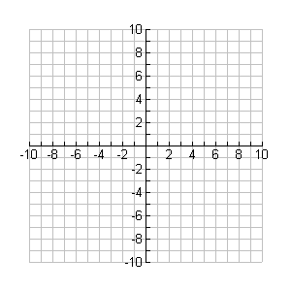

**y**

**x**

f(x) = x3 +2x2 - 4x - 8

In some special cases, we may be able to factor a high degree polynomial using grouping strategies; see below.

Example 3

Factor the following expressions by using a grouping strategy.

a)  b) 