**MHF4U – Rational Functions Quiz Name: _______________**

1. Sketch the function $f\left(x\right)= -(x-1)(x+3)$ then use this graph to sketch the function .

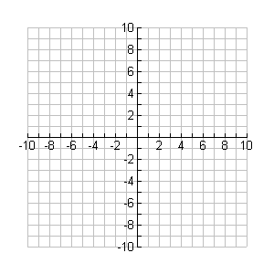

**y**

**x**

1. Sketch the following rational function $g\left(x\right)= \frac{-x^{3}-x^{2}+11x-10}{x^{2}-3x+2}.$ Include x/y – Intercepts.



**y**

**x**

1. Solve the following rational equation: $\frac{x+2}{x}-\frac{x+2}{x-1}=-2$
2. Solve the following inequality: $-2x≤\frac{6x-16}{x-1}$