Hmwk: pg 330#1-8(odd), 9, 10, (11), 13

**Radian Measure and Special Triangles**

Recall:

An angular measure '', in radians, is the ratio of arc length 'a' to the length of the radial arm 'r'.

a

r

θ

$θ(in radians)=\frac{a}{r}$

r

$180^{o}=π radians$

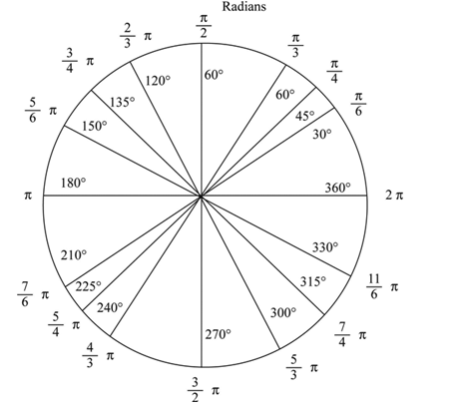On a unit circle, some of the angular measures in degrees and radians appear as follows.

90o

Grade 11 Cheat Sheet for Trigonometry

Special Triangles Unit Circle Trigonometric Ratios

**(0, 1)**

** **

**S**

**P(cos** θ,  **sin** θ**)**

**A**

**Angle in Standard Position**

2

1



**45o**

**60o**

** **

**(-1, 0)**



**Related**

**Angle**

β

**(1, 0)**

θ



**30o**

** **

**45o**

**T**

**C**

**Initial Arm**

**Terminal Arm**

**(0, -1)**



Example 1

Use a sketch and the CAST rule to determine the related angle and sign of each trigonometric ratio.

a)  b)  c) $\sec\left(\frac{5π}{3}\right)$

Example 2

Evaluate the exact value for each of the following.

a)  b)  c) 

Example 3

Each point below lies on the end of a terminal arm.

* Draw a sketch to represent the scenario.
* Determine the value of r using .
* Determine one of the primary trig ratios.
* Calculate the radian value of the angle in standard position .

a) (1, 4) b) (-5, -4)

Example 4

Solve for the angle θ; $0≤θ≤2π$. Use special triangles if applicable.

a) $\sin{θ}=\frac{1}{2}$ b) $\cos{θ}=-\frac{\sqrt{2}}{2}$

c) $\tan{θ=4}$ d) $\sin{θ= - 0.3}$