Grade 11 Review – Quadratic Functions
A quadratic function can be expressed in three forms; vertex, standard and factored. Each form provides valuable information about the graph of the function.
Example 1
For each quadratic relation below, determine the x-intercepts, y-intercepts, and vertex then graph the parabola.
a) y = x² – 6x + 5 b) y = – 2x² – 12x – 16

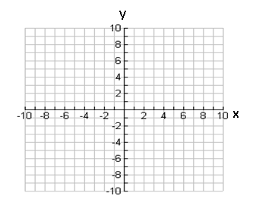
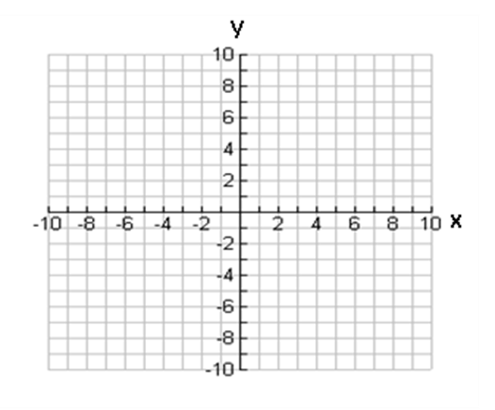

Example 2
Create a quadratic function that passes through the point (2, -10) and has a vertex (-1, 8).

Example 3
Create a quadratic function that passes through the point (8, 21) and has x-ints of 1 and 7.

The discriminant (b² – 4ac) can be used to determine the number of roots of a quadratic equation.
Example 4
Determine the number of solutions for each quadratic equation; do not solve.
a) 2x² – 20x + 50 = 0 b) x² = - 2x - 3

Quadratic equations can be solved by factoring or using the quadratic formula
Example 5
Solve the following quadratic equation using both methods.
6x² + 7x – 5 = 0

Grade 11 Review – Exponential Functions
Rational exponents are evaluated by separating the exponent into a power and root.
Example 6
Evaluate the following.
a) $4^{\frac{5}{2}}$ b) ${27}^{-\frac{4}{3}}$ c) ${(16x^{8})}^{\frac{3}{4}}$

Exponential equations are solved by finding a common base or using trial and error.
Example 7
Solve each exponential equation
a) $4^{2x-1}=8^{x+3}$ b) $2^{10x-1}=\frac{1}{16}$ c) $3^{x}=15$

Exponential functions can be used to model real world scenarios such as compound interest investments, general exponential growth and decay problems or half-life and doubling time scenarios.
$A=P{(1+i)}^{n}$ $y=a{(1±r)}^{x}$ $y=a{\left(\frac{1}{2}\right)}^{\frac{t}{h}}$ $y=a{\left(2\right)}^{\frac{t}{d}}$
Example 8
a) Shalen invests $10000 at 6% compounded semi-annually. How long will it take until the investment is worth $20000?

b) Ben purchases a car for $40000 that depreciates by 16% each year. How much will the car be worth in a decade?

Practice
1. Determine the x-intercepts, y-intercepts and vertex of the quadratic function y = -2x² + 4x + 6 then sketch the function.
2. Determine the equation of a quadratic function that has a vertex of (4, 8) and an x-intercept of 6.
3. Determine the equation of a quadratic function that has a y-int of -27 and has x-intercepts of 3 and -3.
4. How many solutions does each quadratic equation have?
a) x² – 8x + 10 = 0 b) x² + 4x + 10 = 0
5. Solve the following quadratic equations.
a) 2x² + 7x + 3 = 0 b) x² + 5x + 7 = 0
6. Evaluate each power.
a) ${16}^{\frac{3}{2}}$ b) ${125}^{-\frac{2}{3}}$
7. Evaluate the following.
a) $6^{3x-5}={36}^{x+3}$ b) $5^{x}=1050$
8. The amount of bacteria in a Petrie dish grows exponentially with time. If there is initially 200 cells in the dish and the amount grows by 25% every hour, how long will it take until there is 10000 cells?
Answers
1. x-ints: -1, 3, y-int: 6, vertex: (1, 8), 2. y = -2(x - 4)² + 8, 3. y = 3(x - 3)(x + 3)
4.a)2, b) none , 5.a) x = -1/2 or -3, b) No Sol^{n}, 6.a) 64, b) 1/25 (0.04),
7.a) x = 11, b) x = 4.32, 8. 17.5 hours

