Hmwk: pg 417 # 5ac, 8, 9ac, 10ace, 11cegijl, 16a

**Proving Trigonometric Identities: Part 1**

Trigonometric identities can be proven true or untrue by graphing; this method is typically convenient if you have access to graphing technology.

Example 1

Prove that the following identity is true by graphing.



Graph . Graph 

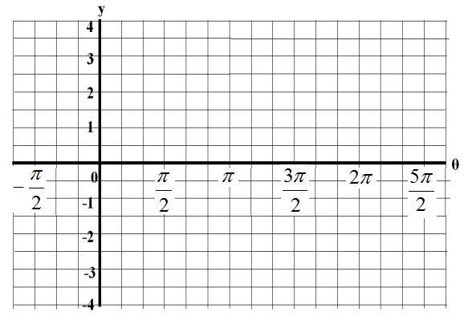

Example 2

Identities can be disproven by finding any single value that makes the mathematical statement false. Show that the following statement is false.



Choose an arbitrary value for θ and evaluate each side.

Let . Let .

Example 3

Trigonometric identities can be proven true algebraically by making one side of the equation look like the other.

Note: Keep left side and right side separated.

Prove the following:

a) 

Hint: It is often strategic to change tanθ to sinθ and cosθ using the identity.

b) 

Hint: Start working with the more detailed side.

c)

Hint: Can anything be factored out?