Name: __________________

**__**

**15**

**Polynomial Functions – Mid Unit Quiz (Formative)**

1. Complete the table below for the function f(x) = -3x4 - 6x2 + 21x – 8

**__**

**3**

|  |  |
| --- | --- |
| Maximum number of turning points |  |
| Maximum number of x-intercepts |  |
| End Behaviours |  |

1. Divide the following:
2. (x4 + 3x2 - 2x + 5) ÷ (x - 1) b) (x4 + 2x2 - 3x - 1) ÷ (x2 + 1)

**__**

**4**

1. Determine the x-intercepts, y-intercept, and end behaviours. Sketch the function.

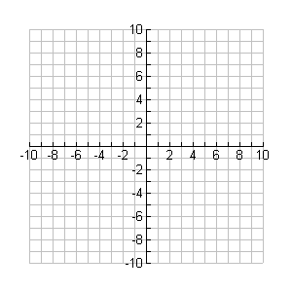

**y**

**x**

f(x) = -2x3 - 6x2 + 8 x - intercepts:

y – intercept:

**__**

**4**

end behaviours:

1. Solve the following polynomial equation: x3 + 2x2 = 9x + 18

**__**

**4**