Hmwk: pg 56-57 #1, 2a, 3a, 4a, 5abc, 7, 8, pg 16 #4, 5

**Operations with Functions**

If two functions have domains that overlap, they can be added, subtracted or multiplied to create a new function on the shared portion of the domain.

The operations can be performed on functions represented in multiple forms.

**Graphs**

Operations on functions represented by graphs can be done on the dependent variable across common parts of the domain.

Consider the two functions below:

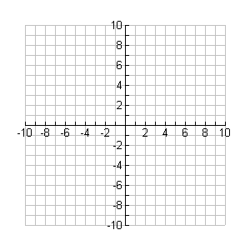

**y**

**x**

g

**f**

Create graphs to represent the following:

a) f + g b) fg



**y**

**x**



**y**

**x**

**Set (Collection of Data Points)**

f = {(-5, 2), (-3, 1), (-1, 7), (3, 4), (6, 5)}

g = {(-5, 3), (-3, -2), (0, 7), (3, -5), (6, -2), (7, 10)}

Determine the following:

a) f + g b) fg

**Equations**

Consider the following functions:

f(x) = x3 + 6x g(x) = 2x - 1

Determine the following:

a) h(x) = f(x) - g(x) b) m(x) = f(x)g(x)

Note: The degree of a function is the highest exponent found on any term in a polynomial function.

What is the degree the functions h(x) and m(x) above?

a) b)

**Absolute Value**

Highlight the portions of the numberline represented by each:

a) |x|3



b) |x|5



c) |x|-7



d) |x| > - 2

