**Logarithms and Exponentials: Practice**

1. Solve for x **without** using a calculator.

a) $x=\log_{3}{81}$ b) $x=\log_{6}{6\sqrt{6}}$ c) $x=\log{(-100)}$

d) e) f)

g) h) i)

2. Determine the inverse of each function.

a) b)

3. Graph the following and state the domain and range.

a) $y=-3\log_{10}\left(2x-4\right)+1$ b)

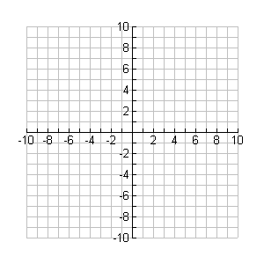

**y**

**x**



**y**

**x**

Domain: _____________ Range: ____ Domain: _______________ Range: ____

4. Solve each exponential equation for x.

a) b)

c) d)

e) f)

5. Write the following as sums and differences of logarithmic expressions where each term is in the form 

a) b)

6. Solve each logarithmic equation for x.

a) b)

c) d)

e) f)

7. How much more intense is the sound emitted from a lawnmower (107 dB) in comparison to normal conversation (65dB)?

 where 

8. A student figures that their grade on the final exam, G, in percent, is a function of the total amount of time studying, t in hours, prior to the assessment as follows:

$$G(t)=40\log\left(t+1\right)+50$$

a) What grade should this student expect to get on the final exam if they study for 2 hours?

b) At what rate will the grade increase when the amount of studying increases from 2 hours to

5 hours?

c) At what rate is the grade increasing when this student studies for only 1 hour?

**Answers:**

1. a) 4 b) 3/2 c) No Soln d) 2 e) 16 f) -4 g) Q h) 71 i) 5

2. a) b)

3. See graph online.

4. a) 2.93 b) 4.25 c) 2 d) 2.26 e) 2.18 f) -1

5. a) b)

6. a) 6 b) 5 c) ½ d) -4.5 e) 6 f) 483945637.8

7. IL = 10-1.3 W/m2, IC = 10-5.5 W/m2, Lawnmower sound 15849 times more intense.

8. a) 69% b) 4.01%/hour c) 8.66%/hour