Homework: read pg 450, do pg 451 #1ab, 2ab, 4-11

**Introduction to Logarithms**

A logarithmic function is the inverse of an exponential; they are a useful function for solving exponents.

The parent logarithmic function is written as:



This function is read, "y equals the log of x with base a". When there is no number written for 'a', then the base is ten by default.

The expression  determines what exponent needs to be placed on 'a' so that it equals x.

**Example 1**

Evaluate the following.

a)  b)  c)  d) $log⁡(-100)$

The above expressions can be evaluated using a technique referred to as "splitting". This technique works as follows.



**Example 2**

Use splitting to evaluate the following.

a)  b)  c)  d) $log⁡(-100)$

A basic exponential function and its inverse can be written as follows:

Exponential Function Inverse

 -------->  (Exponential Form)

-------->  (Logarithmic Form)

**Example 3**

Write the inverse of each exponential function in exponential form and logarithmic form.

a)  b)  c) 

**Example 4**

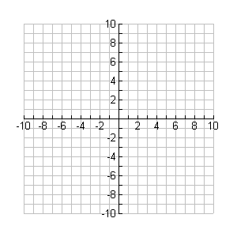

**y**

**x**

Graph the following sets of functions.

|  |  |  |
| --- | --- | --- |
| x |  |  |
| -2 |  |  |
| -1 |  |  |
| 0 |  |  |
| 1 |  |  |
| 2 |  |  |

a) Exponential Functions

|  |  |  |
| --- | --- | --- |
| x |  |  |
| 1 |  |  |
| 2 |  |  |
| 4 |  |  |
| 8 |  |  |

Domain: _______ Range: _________



**y**

**x**

b) The Inverse Functions of a)

Domain: _______ Range: _________