Homework: 353#1, 2, 3, 5, *6, 7ab

**The Graphs of Reciprocal Trigonometric Functions**

Recall: The Graphs of Reciprocal Functions --> 

* points where y = 1 or y = -1 on the parent function coincide as points on the reciprocal function.
* x-intercepts on the parent function are vertical asymptotes on the reciprocal function.
* positive and negative intervals remain the same for both the parent and reciprocal function.
* increasing and decreasing intervals for the parent function are opposite for the reciprocal.

The Reciprocal Trigonometry Functions

  

**Activity**

1. Complete the following table of values (2 decimal places), graph the function, and fill in the blanks.

|  |  |  |  |  |  |  |  |  |  |  |  |  |  |  |  |  |
| --- | --- | --- | --- | --- | --- | --- | --- | --- | --- | --- | --- | --- | --- | --- | --- | --- |
|  |  |  |  | 0 |  |  |  |  |  |  |  |  |  |  |  |  |
|  |  |  |  |  |  |  |  |  |  |  |  |  |  |  |  |  |

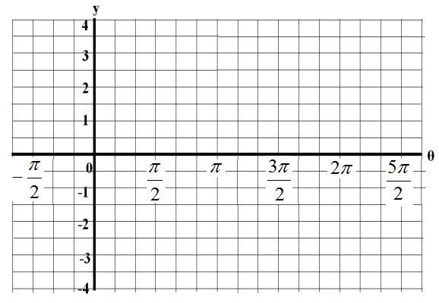Domain: ___________

Range: ____________

Maximum: _________

Minimum: _________

V. Asymptotes: _______

-intercepts: _________

Period: ____________

2. Complete the following table of values (2 decimal places), graph the function, and fill in the blanks.

|  |  |  |  |  |  |  |  |  |  |  |  |  |  |  |  |  |
| --- | --- | --- | --- | --- | --- | --- | --- | --- | --- | --- | --- | --- | --- | --- | --- | --- |
|  |  |  |  | 0 |  |  |  |  |  |  |  |  |  |  |  |  |
|  |  |  |  |  |  |  |  |  |  |  |  |  |  |  |  |  |



Domain: ___________

Range: ____________

Maximum: _________

Minimum: __________

V. Asymptotes: ________

-Intercepts: _________

Period: _____________

3. Complete the following table of values (2 decimal places), graph the function, and fill in the blanks.

Hint: Use the table of values for  and to determine some of these entries.

|  |  |  |  |  |  |  |  |  |  |  |  |  |  |  |  |  |
| --- | --- | --- | --- | --- | --- | --- | --- | --- | --- | --- | --- | --- | --- | --- | --- | --- |
|  |  |  |  | 0 |  |  |  |  |  |  |  |  |  |  |  |  |
|  |  |  |  |  |  |  |  |  |  |  |  |  |  |  |  |  |



Domain: ___________

Range: ____________

Maximum: _________

Minimum: __________

V. Asymptotes: _______

 - intercepts: __________

Period: _____________