Hmwk: pg 272 #1,2-3acefg,4ab,5ad,6abc,9, 10, 14abc

**Graphing Rational Functions: Part 2**

**Strategies**

There are four steps to go through every time you try to graph a rational function:

1. First check to see what values of x make the denominator zero.
   * If this value of x makes both the denominator and numerator zero (indeterminate), then there will be a linear term that can be factored out and there will be a hole.

Ex: 

This function looks like it will have a vertical asymptote at

x = -3 due to the restriction and an oblique asymptote since the

degree of the numerator is one larger than the denominator. However, this

function has neither; it is a line with a hole since 'x + 3'

can be factored out of both the numerator and denominator.

* If this value of x, instead, makes the numerator non-zero, then there is a vertical asymptote at that value of x.

2. Compare the degree of the numerator to the denominator to

determine the location/presence of any oblique/horizontal asymptotes

* If the degree of the numerator is less than the denominator, then there is a horizontal asymptote of y = 0.
* If the degree of the numerator is equal to that of the denominator, then there is a horizontal asymptote which is determined by dividing the leading coefficients.
* If the degree of the numerator is greater than the denominator by exactly one, then there is an oblique asymptote which is determined by dividing the numerator by the denominator and ignoring the remainder.

3. Determine all x and y intercepts by setting the opposite variable to zero

and solving.

4. Investigate the behaviour of the rational function **around the edges of**

**all vertical asymptotes** and at the **end points** (x = +/- infinity).

Practice

1. Consider the function 

a) Does this function have any holes?

b) Does this function have vertical asymptotes? Elaborate.

c) Does this function have horizontal/oblique asymptotes? Elaborate.

d) What are the x and y intercepts for this function?

e) What are the positive and negative intervals for this function?

f) Graph the function and state the domain and range.

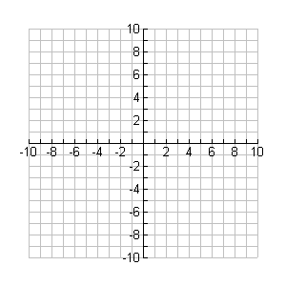

**y**

**x**

2. Graph the following functions; include the x and y intercepts.



**y**

**x**

a) 



**y**

**x**

b) 

c) 



**y**

**x**