**Graphing Rational Functions: Part 1**

rational function - a function that can be expressed as  where  and are each polynomial functions and .

Example 1

Consider the function: .

a) Evaluate the following.

i) f(2.999) ii) f(3) iii) f(3.001)

b) What happens to this rational function when x = 3?

c) Evaluate the function at the end points $x=-∞$ (approx. as -1,000,000) and

$x=∞$ (approx. as 1,000,000).

i) f(-1000000) ii) f(1000000)

d) What value does the function approach at the end points and what does

this suggest about the graph of f(x)?

e) Put the asymptotes on the graph below and sketch the graph of f(x). State the

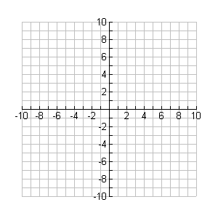

**y**

**x**

domain and range.

Example 2

Consider the function: .

a) Complete the table of value below.

|  |  |
| --- | --- |
| x | f(x) |
| 1 |  |
| 2 |  |
| 3 |  |
| 4 |  |
| 5 |  |
| 6 |  |

b) Evaluate the following.

i) f(3.999) ii) f(4) iii) f(4.001)

c) Factor and simplify the rational function. What happens when x = 4?

d) Graph the function and state the domain and range.



**y**

**x**

Example 3

Consider the function: .

a) i) f(-1.001) ii) f(-1) iii) f(-0.999)

b) What happens to this rational function when x = -1?

c) Perform synthetic division for the rational function f(x); expect a remainder.

d) What does this result tell us about the graph of f(x)?

e) Graph the function.



**y**

**x**

**Summary**

**Given **

* If , then the factor 'x - a' can be factored out of  and  provided that we state that . There is a hole at x = a.
* If , then the function has a vertical asymptote at x = a.
* If the degree of the numerator is less than the degree of the denominator, then has a horizontal asymptote at y = 0.
* If the degree of the numerator = degree of the denominator, then f(x) has a horizontal asymptote as determined by the leading coefficients of

 and .

ex; --> 

* If the degree of the numerator is greater than the degree of the denominator by exactly one, then f(x) has an oblique asymptote which is determined by dividing the dividend by the divisor and ignoring the remainder.

Homework: pg 262 # 1-3