Grade 11 Overall Review Skills
1. Use transformations to graph the following and state the domain and range.
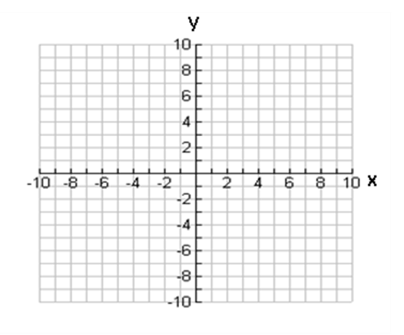
a) $y=\sqrt{2x-6}-4$ b) $y=-2|x+4|+6$
x | $$y=\sqrt{x}$$
0 | 0
1 | 1
4 | 2
9 | 3
x | y=|x|
-2 | 2
-1 | 1
0 | 0
1 | 1
2 | 2

k = k =
d = d =
a = a =
c = c =
Domain: ________ Range: ____________ Domain: ___________ Range: ______________

2. Determine the exact values for each trigonometric ratio.

a) tan(45º) b) sin(240º) c) cos(-405º)

3. Solve each trigonometric equation; $0^{o}≤θ≤{360}^{o}$.
a) $cosθ=-0.5$ b) $tanθ=2$

4. Solve each exponential equation for x.
a) $9^{2x-2}={27}^{x+1}$ b) $2^{x}=100$

5. Simplify each rational expression and state all restrictions (implicit and explicit).
a) $\frac{2x+6}{3x}÷\frac{x+3}{x}$ b) $\frac{4}{2x+2}+\frac{6}{x^{2}-x-2}$

