**Factored Form of Polynomials**

**Review: Factored Form of Quadratic Functions**

1. a) Create a quadratic function that has x-intercepts of 3 and 7 and goes

through the point (5,8).

b) Determine the y-intercept for the above function.

2. Graph the following quadratic functions expressed in factored form.

a) $y = -2(x - 1)(x - 5)$ b)

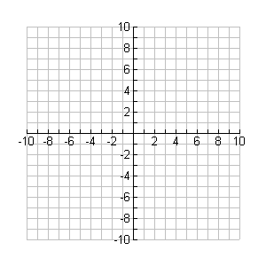

**y**

**x**



**y**

**x**

|  |  |
| --- | --- |
| x | y |
| 0 | -10 |
| 1 | 0 |
| 2 | 6 |
| 3 | 8 |
| 4 | 6 |
| 5 | 0 |
| 6 | -10 |

|  |  |
| --- | --- |
| x | y |
| 1 | 9 |
| 2 | 4 |
| 3 | 1 |
| 4 | 0 |
| 5 | 1 |
| 6 | 4 |
| 7 | 9 |

3. a) List and describe the behaviour of the x-intercept(s) in graph a.

b) List and describe the behaviour of the x-intercept(s) in graph b.

**Sketching Polynomial Functions in Factored Form**

1. Identify critical features of the function then create a sketch:



**y**

**x**

a) $f(x) = 2(x + 1)(x + 3)(x + 5)$

x-intercepts:

y-intercept:

leading coefficient:

degree:

end behaviours:



**y**

**x**

b) $f(x) = (x - 2){(x + 1)}^{3}$

x-intercepts:

y-intercept:

leading coefficient:

degree:

end behaviours:



**y**

**x**

c) $f(x) = -{(x - 1)}^{2}(x + 2)$

x-intercepts:

y-intercept:

leading coefficient:

degree:

end behaviours:

**Key Points**

* End behaviours are determined by the degree of the function and the sign of the leading coeff.
* If a factor appears as (x - d), then the graph has an x-intercept at x = d and the graph is not tangent to the x-axis at that point; behaves like a line crossing x-axis.
* If a factor appears as (x - d)2, then the graph has an x-intercept at x = d. This x-intercept is a turning point for the graph and is tangent to the x-axis at this point; these are local max/mins.
* If a factor appears as (x - d)3, then the graph has an x-intercept at x = d. This x-intercept is a not a turning point for the graph but it is tangent to the x-axis at this point; point of inflection.

**Determining the Equation of Polynomial Functions**

Example 1

Determine the equation of a cubic function that has x-intercepts at 2, 4, and 6 and has a y-intercept of 6. Graph the function.



**y**

**x**

Example 2

Determine the equation of a quartic function that has local maximums at the x-intercepts of 4 and 8 and passes through the point (6, -8). Graph the function.



**y**

**x**

Hmwk: read pg 144-145, do pg 146 #1, 2, 3, 4, 6, 9ab, 10ac, 12, 13