Hmwk: pg 127 # 1, 2, 3, 4, 5, 7, pg 122 # 1ad, 2, 3ab, 4a, 5, 7bc

**Exploring Polynomial Functions**

Polynomial Function - A function of the form

f(x) = anxn + an-1xn-1 + an-2xn-2 + an-3xn-3 + ... + a2x2 + a1x1 + a0

such that

* an, an-1, an-2, an-3, ..., a2, a1, a0 are all real numbers.
* n is a whole number; recall that whole numbers exclude negatives.

Polynomial functions are often written with the powers arranged in descending order. For example;

$$f(x) = 3x^{2} + 5x - 6$$

$$g(x) = 4x^{5} - 3x^{4} + 2x - 1$$

$$h(x) = -3x^{8} - 2x^{3} + 5.8$$

Investigation

Graph the following polynomial functions and state the domain and range:

a) $f(x) = x^{3} -3x + 3$ b)

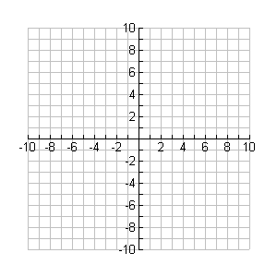

**y**

**x**



**y**

**x**

|  |  |
| --- | --- |
| x | f(x) |
| -3 | -15 |
| -2 | 1 |
| -1 | 5 |
| 0 | 3 |
| 1 | 1 |
| 2 | 5 |
| 3 | 21 |

|  |  |
| --- | --- |
| x | f(x) |
| -3 | 137 |
| -2 | 18 |
| -1 | -7 |
| 0 | 2 |
| 1 | 9 |
| 2 | 2 |
| 3 | -7 |
| 4 | 18 |

Domain: __________ Domain: __________

Range : __________ Range: __________

Properties of Polynomial Functions

* Polynomial functions can have an upper bound or a lower bound but not both.
* The graphs of polynomial functions do not have horizontal or vertical asymptotes.
* The y-intercept of a polynomial function is the constant term. For example; If f(x) = x3 - 2x2 + 5x – 9, the y-int is -9
* The domain of all polynomial functions .

Finite Differences

From a table of values, finite differences can be used to show that a polynomial function is of a certain degree. We already know that for linear relations, the first differences of the dependent variable are constant. For quadratic relations, the second differences are constant.

Practice

Use third and fourth differences to show that the relations in the previous question are cubic and quartic.

a) b)

|  |  |
| --- | --- |
| x | f(x) |
| -3 | 137 |
| -2 | 18 |
| -1 | -7 |
| 0 | 2 |
| 1 | 9 |
| 2 | 2 |
| 3 | -7 |
| 4 | 18 |

|  |  |
| --- | --- |
| x | f(x) |
| -3 | -15 |
| -2 | 1 |
| -1 | 5 |
| 0 | 3 |
| 1 | 1 |
| 2 | 5 |
| 3 | 21 |