Homework: pg 136 #1-3, 4abcd, 5, 6ac, 7, 8, 10ab, 11, 13, (16)

**Characteristics of Polynomial Functions**

Polynomial functions have common features depending on the sign of the leading coefficient and the degree.

Leading Coefficient - the coefficient of the term with the highest degree in a polynomial; usually it is the first coefficient.

1. Examine the following functions and state their degree.

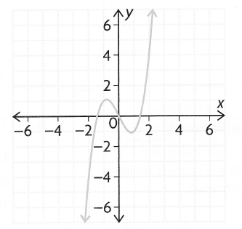a)  b) 

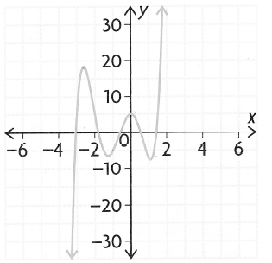

degree = __ degree = __

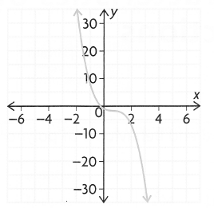c) d) 

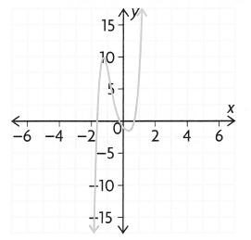

degree = __ degree = __

All of the functions above have an **_____** degree.

**Key Features of Odd Degree Functions**

*End behaviours*

* If the leading coefficient is positive, then the function extends from the ______ quadrant to the _______ quadrant; ie as , and as ,.
* If the leading coefficient is negative, then the function extends from the ___ quadrant to ________ quadrant; ie as , and as ,.

*Turning Points*

* These polynomials will have at most "n - 1" turning points; notice in 'd)' that there are only ____ turning points even though the function is of degree ___.

*Number of Zeroes (x-intercepts)*

* They will have at least ____ x-intercept with a maximum of 'n' x-intercepts.

2. Examine the following functions and state their degree.

a)  b) 

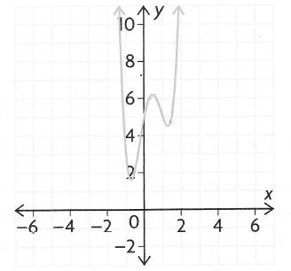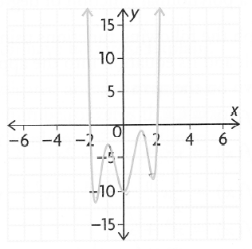

degree = ___ degree = ___

c)  d) 

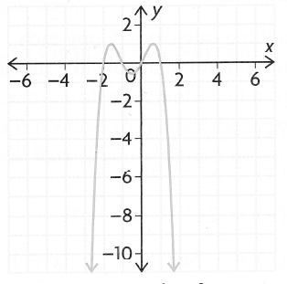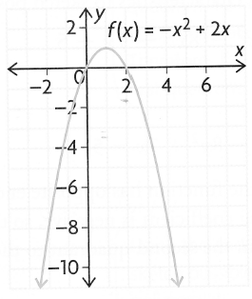

degree = ___ degree = ___

All of the functions above have an **_____** degree.

**Key Features of Even Degree Functions**

*End behaviours*

* If the leading coefficient is positive, then the function extends from the ______ quadrant to the _______ quadrant; ie as , and as ,.
* If the leading coefficient is negative, then the function extends from the ___ quadrant to ________ quadrant; ie as , and as ,.

*Turning Points*

* These polynomials will have at most "n - 1" turning points. They will have at least ____ turning point.

*Number of Zeroes (x-intercepts)*

* They may not have any x-intercepts but can have a maximum of 'n' x-intercepts.

**Symmetry of Polynomial Functions**

Polynomial functions can have odd, even or no symmetry. If a polynomial does have symmetry, it tends to follow the degree. ie; If a quartic function (degree 4) has symmetry then it will be even since the degree is even, but not all quartics have symmetry.

**\*\*\*CAREFUL!! While the symmetry and degree of a function are similar, they are not necessarily the same concept. \*\*\***

**Practice**

|  |  |
| --- | --- |
| Degree |  |
| Even or Odd Degree |  |
| Sign of Leading  Coefficient |  |
| Max # of  Turning Points |  |
| Max # of  x-ints |  |
| End Behaviours |  |

Given the following functions, complete the tables below.

a)  b)  c)

|  |  |
| --- | --- |
| Degree |  |
| Even or Odd Degree |  |
| Sign of Leading  Coefficient |  |
| Max # of  Turning Points |  |
| Max # of  x-ints |  |
| End Behaviours |  |

|  |  |
| --- | --- |
| Degree |  |
| Even or Odd Degree |  |
| Sign of Leading  Coefficient |  |
| Max # of  Turning Points |  |
| Max # of  x-ints |  |
| End Behaviours |  |