Hmwk: pg 136#1-3, 4abcd, 5, 6ac, 7, 8, 10ab, 11, 13, (16)

Characteristics of Polynomial Functions

Polynomial functions have common features depending on the sign of the leading coefficient and the degree.

Leading Coefficient - the coefficient of the term with the highest degree in a polynomial; usually it is the first coefficient.

1. Examine the following functions and state their degree.

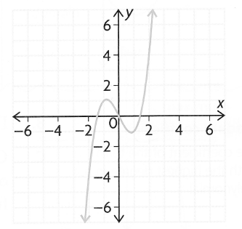a) 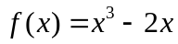 b) 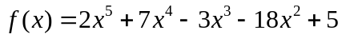
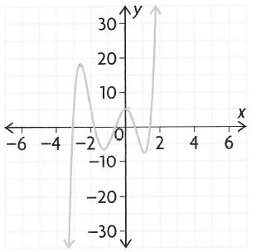

degree = __ degree = __

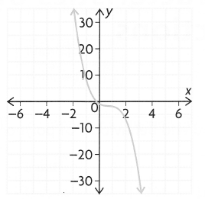c)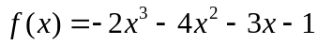 d) 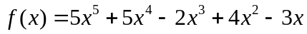
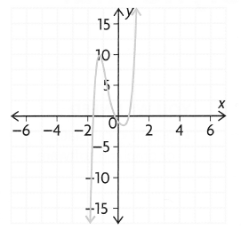

degree = __ degree = __

All of the functions above have an _____ degree.
Key Features of Odd Degree Functions

End behaviours
- If the leading coefficient is positive, then the function extends from the ______ quadrant to the _______ quadrant; ie as ,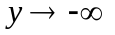 and as ,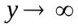.
- If the leading coefficient is negative, then the function extends from the ___ quadrant to ________ quadrant; ie as ,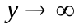 and as ,.

Turning Points
- These polynomials will have at most "n - 1" turning points; notice in 'd)' that there are only ____ turning points even though the function is of degree ___.

Number of Zeroes (x-intercepts)
- They will have at least ____ x-intercept with a maximum of 'n' x-intercepts.

2. Examine the following functions and state their degree.

a) 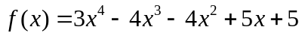 b) 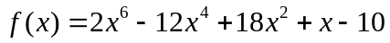
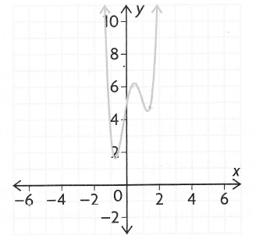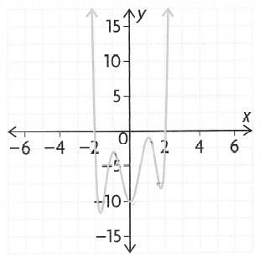

degree = ___ degree = ___

c) 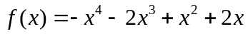 d) 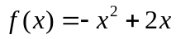
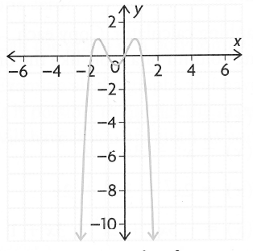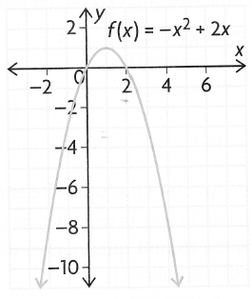

degree = ___ degree = ___

All of the functions above have an _____ degree.
Key Features of Even Degree Functions

End behaviours
- If the leading coefficient is positive, then the function extends from the ______ quadrant to the _______ quadrant; ie as , and as ,.
- If the leading coefficient is negative, then the function extends from the ___ quadrant to ________ quadrant; ie as , and as ,.

Turning Points
- These polynomials will have at most "n - 1" turning points.

Number of Zeroes (x-intercepts)
- They may not have any x-intercepts but can have a maximum of 'n' x-intercepts.

Symmetry of Polynomial Functions

Polynomial functions can have odd, even or no symmetry. If a polynomial does have symmetry, it tends to follow the degree. ie; If a quartic function (degree 4) has symmetry then it will be even since the degree is even, but not all quartics have symmetry.

***CAREFUL!! While the symmetry and degree of a function are similar, they are not necessarily the same concept. ***

Practice
Degree

Even or Odd Degree
Sign of Leading
Coefficient
Max # of
Turning Points
Max # of
x-ints
End Behaviours

Given the followig functions, complete the tables below.

a) 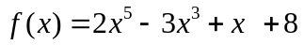 b) 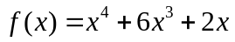 c)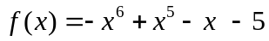
Degree

Even or Odd Degree
Sign of Leading
Coefficient
Max # of
Turning Points
Max # of
x-ints
End Behaviours

Degree

Even or Odd Degree
Sign of Leading
Coefficient
Max # of
Turning Points
Max # of
x-ints
End Behaviours

