**Average Rate of Change**

A train leaves Guelph and is traveling towards Montreal. Its distance from Guelph is given in the table below.

distance

(km)

|  |  |
| --- | --- |
| **time (hours)** | **distance (km)** |
| **0** | **60** |
| **0.5** | **135** |
| **1** | **210** |
| **1.5** | **285** |
| **2** | **360** |

|  |  |  |  |  |  |  |  |  |  |  |  |  |
| --- | --- | --- | --- | --- | --- | --- | --- | --- | --- | --- | --- | --- |
|  |  |  |  |  |  |  |  |  |  |  |  |  |
|  |  |  |  |  |  |  |  |  |  |  |  |  |
|  |  |  |  |  |  |  |  |  |  |  |  |  |
| 500 |  |  |  |  |  |  |  |  |  |  |  |  |
|  |  |  |  |  |  |  |  |  |  |  |  |  |
| 400 |  |  |  |  |  |  |  |  |  |  |  |  |
|  |  |  |  |  |  |  |  |  |  |  |  |  |
| 300 |  |  |  |  |  |  |  |  |  |  |  |  |
|  |  |  |  |  |  |  |  |  |  |  |  |  |
| 200 |  |  |  |  |  |  |  |  |  |  |  |  |
|  |  |  |  |  |  |  |  |  |  |  |  |  |
| 100 |  |  |  |  |  |  |  |  |  |  |  |  |
|  |  |  |  |  |  |  |  |  |  |  |  |  |
| 0 | 1.0 |  |  |  | 2.0 |  |  |  | 3.0 |  |  |  |

time(hours)

a) Create a graph to represent this relation; distance depends on time.

b) Use the graph to determine the rate of change (speed).

$average rate ofchange=\frac{rise}{run}$

$=\frac{Δd}{Δt}$

$=\frac{d_{2}-d_{1}}{t_{2}-t_{1}}$ $=\frac{d(2)-d(0)}{2-0}$

c) Use the table of values to determine the average rate of change from 0.5 hours to 1.5 hours.

$average rate ofchange=\frac{Δd}{Δt}$

$=\frac{d_{2}-d_{1}}{t_{2}-t_{1}}$

d) Did the rate of change differ in your answers for c) or d)?

For linear relations, the rate of change is the same as the slope and does not depend on the chosen interval. For non-linear relations, however, the rate of change will depend on the chosen interval.

**Example 1**

The population of a city is shown in the graph below.

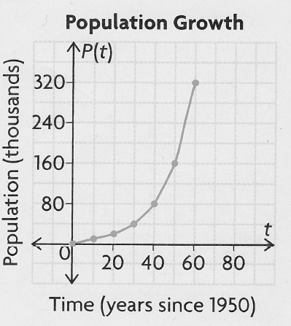

a) Is the rate of change for this relation constant? Explain.

b) What is the average rate of change from 1970 to 2010?

c) What is the average rate of change from 1950 to 1980?

d) Why do we use the term "average" rate of change in b) and c)?

It is also possible to determine an average rate of change from an equation.

**Example 2**

Yuan puts $5000 into an investment that earns 8% interest compounded annually. The value of his investment as a function of time in years is given as follows:

A(t) = 5000(1.08)t

a) Is this relation linear?

b) Is the rate of change constant? ie; will the investment grow by

the same amount every year?

c) What is the average rate of change from 0 years to 5 years?



d) What is the average rate of change from 5 years to 10 years?



e) What is happening to the rate of change as time elapses?

Hmwk: pg 76 #1ace, 2ab, 3, 4, 6, 8ai,iii, 9, 10, 13, (15) + read pg 75