Homework: pg 10 # 1, 2, 3, 4ac, 6, 7, 8, 9, 11

**What is a Function?**

**Function** – is a relationship such that for each input value there is at most only one output value; typically, we designate the input value as ‘x’ and output value as ‘y’.

A relationship can be classified as a function by examining the equation, the table of values, a mapping of inputs and outputs, or the graph.

**Equation**

Consider the equation $y = 2x + 3$:

y = 2x +3

x

y

For this example, if we randomly assign the value x = 6, we get…

$$y = 2x + 3$$

$y =$

$y =$

The relationship y = 2x + 3 (is/ is not) a function since it has at most _____ output for any input.

Consider the equation $y = ±\sqrt{x+3}$:

$y = +\sqrt{x+3}$

$y = ±\sqrt{x+3}$

x

y

$y = -\sqrt{x+3}$

For this example, if we randomly assign the value x = 6, we get…

$y = ±\sqrt{x+3}$ $y =$

$y =$

The relationship $y = ±\sqrt{x+3}$ (is/ is not) a function since it has ______ _____ _____ output for some inputs.

# Table of Values

|  |  |
| --- | --- |
| x | y |
| 1 | 4 |
| 2 | 6 |
| 2 | 8 |
| 5 | 13 |

|  |  |
| --- | --- |
| x | y |
| -5 | 4 |
| -2 | 4 |
| 1 | 7 |
| 3 | 9 |

The first table (is/ is not) a function since when x = 2, y can be _____________ values.

The second table (is/ is not) a function since each value of x has only ______ output.

# Mapping

## Input Output Input Output

1 5 7

3 3 3 1

8 1 -2 19

10 -4 2

The first relation (is/ is not) a function since each input maps to ___ output.

The second relation (is/ is not) a function since some inputs map to _____________ outputs.

**Vertical Line Test with Graph**

[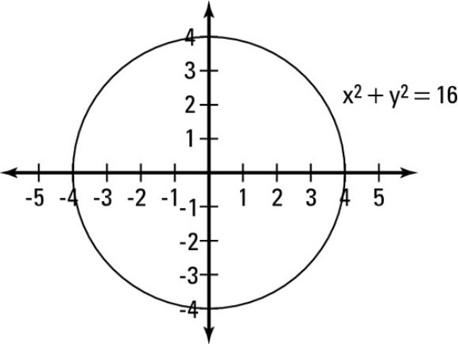](http://www.google.ca/url?sa=i&rct=j&q=&esrc=s&source=images&cd=&cad=rja&uact=8&ved=0ahUKEwipttnPkfLRAhUlyoMKHfhUCzwQjRwIBw&url=http%3A%2F%2Fwww.dummies.com%2Feducation%2Fmath%2Fcalculus%2Fhow-to-graph-a-circle%2F&psig=AFQjCNGndXHkyq_V_sKWcTy1Up1HE8WELw&ust=1486149808558942)The vertical line test is conducted by visualizing a vertical line moving across the Cartesian grid from left to right. A relationship is considered to be a function if the vertical line never intersects the graphed relationship at more than one point at any instant.

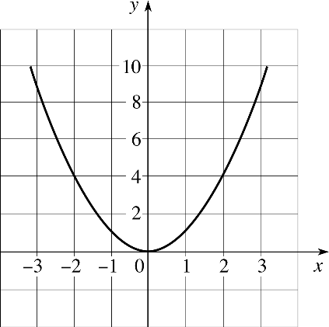

The relation y = x2 (is/ is not) a function since the vertical line never crosses the graphed relationship at more than one point.

The relation  (is/ is not) a function since the vertical line often crosses more than one point on the graph.