**Hmwk: pg 299 # 2i, ii, iii, 3(use a unit circle), 6i, ii, 10**

**Trigonometry and the Cartesian Grid**

Draw a circle on the Cartesian grid below with radius 5 centered about the origin and label the quadrants I, II, III, and IV.

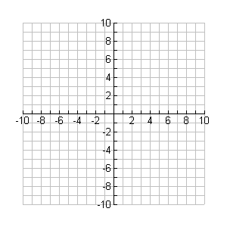

**y**

**x**

Draw a terminal arm that goes from the origin to the point P(3, 4).

The angle in standard position (θ) is an angle measured counter-clockwise from the initial arm to the terminal arm. The initial arm is always the positive x-axis. Label the angle in standard position.

From the diagram, we can see that the Pythagorean Theorem can be used to determine the length of the terminal arm (the radius of the circle). ie;

Since c2 = a2 + b2

r2 = x2 + y2

Determine the three primary trigonometric ratios for the angle in standard position above.

sin θ = cos θ = tan θ =

From the above work we can see that for acute angles,

  

## The above set of equations can also be used for obtuse and reflex angles in standard position.

## Example 1

Determine the sinθ, cosθ, and tanθ for the angle in standard position.

a) P(-4, 4) b) P(3, -4)



**y**

**x**



**y**

**x**

Isolate the following equations for 'x' and 'y' by cross multiplying:

 

These new equations can be used to determine the Cartesian coordinates of a point that lies on a circle of radius 'r' with an angle in standard position 'θ'.

**Example 2**

Determine the coordinates of a point that lies on the end of a terminal arm with radius 8 and an angle in standard position of 230o. Use a diagram as an aid.