Transformations of Sinusoidals: Part 2

# The Effect of ‘k’ on Sinusoidals

For sinusoidal functions of the form:

$y = a sin\left[k(θ-d)\right]+c$ or $y=a cos\left[k(θ-d)\right]+c$

k🡪 Period compression/expansion (and a reflection about the y axis)

When |k| is larger than 1, the period of a sinusoidal is compressed.

When |k| is smaller than 1, the period of a sinusoidal is expanded.

When k is negative, the points (graph) is reflected about the y-axis.

# Recall

The 5 key points for a sinusoidal function are seen in the graphs below.

$y=\sin{θ}$ $y=\cos{θ}$

y

y

1

1

θ

θ

360o

360o

180o

180o

- 1

- 1

|  |  |
| --- | --- |
| θ |  |
| 0o | 1 |
| 90o | 0 |
| 180o | -1 |
| 270o | 0 |
| 360o | 1 |

|  |  |
| --- | --- |
| θ |  |
| 0o | 0 |
| 90o | 1 |
| 180o | 0 |
| 270o | -1 |
| 360o | 0 |

# Example 1

# Determine the value of k, the phase (d), then graph the function.

# Use the graph to determine the period.

a) y = sin3θ b) y = cos(2θ – 120o)

k = d = k = d =

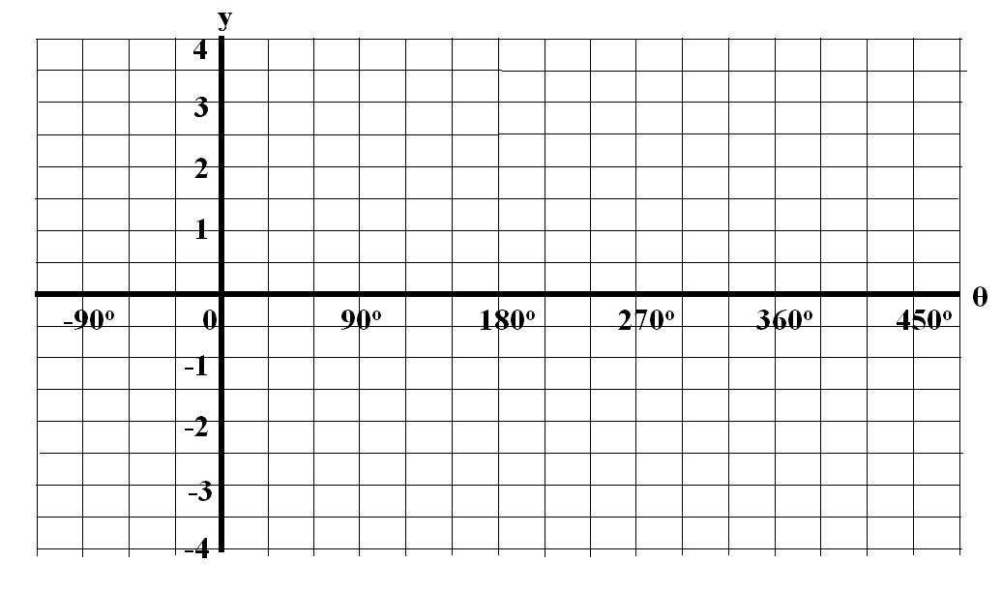

Period = Period =

# The Relationship Between the Constant ‘k’ and the Period ‘T’

In the first example above, the period was 120o and k = 3.

## For the second example, the period was 180o and k = 2.

The constant k is related to the period, T, by the equations:

 or  

## Example 2

For each sinusoidal listed below, determine the period (T) and phase (d).

a) y = sin(4θ – 180o) b) y = cos(0.25θ + 15o)

# Example 3

Create a sinusoidal function of the form y = sinkθ then graph the function.

a) T = 240o b) T = 480o



# The Box Method for Graphing Sinusoidal Functions

The following procedure can be used to graph sinusoidal functions.

1. Extract the values of k, d, a, and c from the equation.
2. Draw a horizontal dotted line at $y = c$ to represent the line of equilibrium.
3. From the intersection of the y-axis and the line of equilibrium move left or right according to the phase shift, d; this is the left marker of the box.
4. Extend that marker up and done by the amplitude (amplitude = |a|). This represents the left side of the box.
5. Complete the box by extending to the right a width that corresponds to the period of the sinusoidal ($T=\frac{360°}{|k|}$).
6. Draw one cycle of the sinusoidal in the box taking the reflection values of k and a into consideration for reflections. Extend the pattern across the grid.

**Example 4**

Graph the sinusoidal functions using the box method; state the domain and range.

a) $y=-2\cos\left(2θ-60°\right)+1$ b) $y=\sin\left(-θ+90°\right)-2$



**Homework:** Complete graphs below **+** pg 379 # 1def, 2cdf, 3 Pg 383 #1acde, 9, 10

Use transformations to graph the following then state the domain and range.

**a)  b) **

**c)  d) **



**e)  f) **

