Transformations of Sinusoidals: Part 1

**Recall:**

Transformations of functions of the form $y = af\left[k(x-d)\right]+c$

k 🡪 horizontal compression/expansion and reflection

d 🡪 horizontal shift

a 🡪 vertical expansion/compression and reflection

c 🡪 vertical shift

# Transformations of Sinusoidals

For sinusoidal functions of the form:

$y = a sin\left[k(θ-d)\right]+c$ or $y=a cos\left[k(θ-d)\right]+c$

k 🡪 period compression/expansion and reflection

d 🡪 phase shift

a 🡪 vertical expansion/compression and reflection (amplitude = $|a|$)

c 🡪 vertical displacement (location of the line of ‘equilibrium’ at y = c)

It is important to note that this extra terminology is reserved for use when discussing sinusoidal functions but the numerical constants (k, d, a, and c) continue to produce the same transformations as they have in previous units.

# Activity

Create sketches of the parent functions $y=\sin{θ}$ and $y=\cos{θ}$.

$y=\sin{θ}$ $y=\cos{θ}$

y

y

1

1

θ

θ

360o

360o

180o

180o

- 1

- 1

# The 5-point Method

To graph a sinusoidal function:

1. Apply transformations to the 5 key points from the relevant table below.

|  |  |
| --- | --- |
| θ | y=sinθ |
| 0o | 0 |
| 90o | 1 |
| 180o | 0 |
| 270o | -1 |
| 360o | 0 |

|  |  |
| --- | --- |
| θ | y=cosθ |
| 0o | 1 |
| 90o | 0 |
| 180o | -1 |
| 270o | 0 |
| 360o | 1 |

2. Extend the pattern beyond the 5 points on the graph then draw a smooth curve.

# Examples

Graph the following then state the domain and range.

a) $y=\sin\left(θ+30°\right)+2$ b)

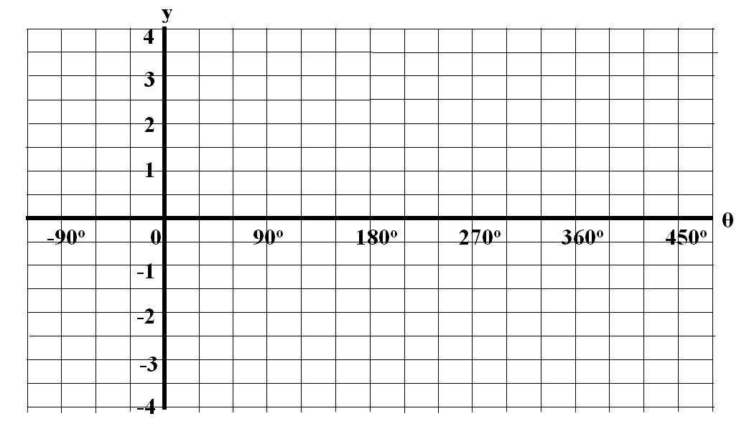

c) $y=-2(sin{θ+1)}$ d) $y=1-\cos{(θ-45°)}$



**Homework:** Complete graphs below **+** pg 379 #1abc, 2abe, pg 383 # 1b, 4ad, 6ac

Use transformations to graph the following then state the domain and range.

**a)  b) **

**c)  d) **



**e)  f) **

