Transformation of Functions: Part 2

If we start with the parent function

y = f(x)

We can apply several transformations to this function to produce a new equation in terms of f(x)

outside of the function

y = a f (k(x - d)) + c

inside function

where

* ‘x’ and ‘y’ are the independent and dependent variables respectively.
* ‘f( )’ is some function.
* ‘k’ represents a horizontal expansion/compression/reflection.
* ‘d’ represents a horizontal shift
* ‘a’ represents a vertical expansion/compression/reflection.
* ‘c’ represents a vertical shift

Exercise

Given a starting function f(x), express the second function in terms of f(x) and determine the values for k, d, a and c.

a)  🡪  b)  🡪 

Summary of Transformations

There are a few ideas worth remembering to help understand what the constants k, d, a, and c do to the graph of a parent function.

1. Multipliers such as ‘a’ and ‘k’ expand, compress and reflect.
2. Constants that add or subtract such as ‘c’ and ‘d’ shift the function.
3. Constants inside the function deal with horizontal transformations.
4. Constants outside the function deal with vertical transformations.
5. For constants inside the function; THINK OPPOSITE! Large values of k actually compress the function rather than expand. When a number is added to x, it actually shifts the function left and not right.

Order of Transformations

The order for which transformations are carried out is critical to producing the correct graph for a given function. A horizontal expansion/compression/reflection needs to occur before horizontal shifts:

* k before d

A vertical expansion/compression/reflection needs to occur before vertical shifts:

* a before c.

For a function expressed in the form,

y = a f (k(x - d)) + c

It is ideal to perform transformations dealing with the constants

k, d, a, c in that order.

# Activity

Graph the parent functions on the left by using the table of values, then graph the functions on the right using a set of transformations.

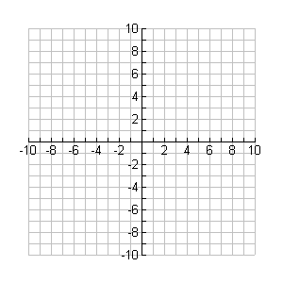

**y**

**x**



**y**

**x**

**a)  **

|  |  |
| --- | --- |
| **x** | **y** |
| **-2** |  |
| **-1** |  |
| **0** |  |
| **1** |  |
| **2** |  |



**y**

**x**



**y**

**x**

**b)  **

|  |  |
| --- | --- |
| **x** | **y** |
| **0** |  |
| **1** |  |
| **4** |  |
| **9** |  |

**c)  **



**y**

**x**



**y**

**x**

|  |  |
| --- | --- |
| **x** | **y** |
| **-2** |  |
| **-1** |  |
| **0** |  |
| **1** |  |
| **2** |  |