**Homework:** Complete Below + pg 251 #1-3, 9, (12)

Graph the functions below. Determine the y-int, equation of the asymptote, and state the domain and range.

a)  b) 

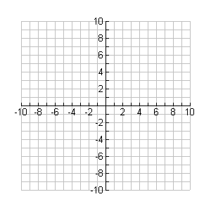

**y**

**x**



**y**

**x**

k = k =

d = d =

a = a =

c = c =

y-int: y-int:

Eqn of Asymptote : Eqn of Asymptote :

Domain: Domain:

Range: Range:

c)  d) 



**y**

**x**



**y**

**x**

k = k =

d = d =

a = a =

c = c =

y-int: y-int:

Eqn of Asymptote : Eqn of Asymptote :

Domain: Domain:

Range: Range: