**Part 2: Transformation of Exponential Functions**

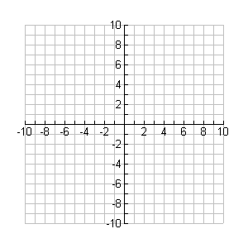

**y**

**x**

Graph the following parent functions.

a) $y = 2^{x}$ b) $y={\left(\frac{1}{2}\right)}^{x}$

|  |  |
| --- | --- |
| x | y |
| -2 |  |
| -1 |  |
| 0 |  |
| 1 |  |
| 2 |  |

|  |  |
| --- | --- |
| x | y |
| -2 |  |
| -1 |  |
| 0 |  |
| 1 |  |
| 2 |  |



**y**

**x**

c) $y=3^{x}$ d) $y={\left(\frac{1}{3}\right)}^{x}$

|  |  |
| --- | --- |
| x | y |
| -2 |  |
| -1 |  |
| 0 |  |
| 1 |  |
| 2 |  |

|  |  |
| --- | --- |
| x | y |
| -2 |  |
| -1 |  |
| 0 |  |
| 1 |  |
| 2 |  |

Each one of these exponential functions above is considered to be a unique parent function. Mathematical methods do exist to transform an exponential function such as

y = 2x to y = 3x but these techniques go beyond the scope of this course.

For simplicity, we will assume that all functions above are distinct parent functions.

If an exponential function is represented in the form:

f(x) = a(b)[k(x - d)] + c

such that k is a positive value then:

If b > 1, then the function represents an exponential _________.

If 0 < b < 1, then the function represents an exponential ________.

Furthermore, we can confirm from the previous graphs the following:

* The horizontal asymptote is the line y = 0.
* The y-intercept is y = 1.

**Example**

Graph the following and state the domain and range:

a)  b) 



**y**

**x**



**y**

**x**

k = k =

d = d =

a = a =

c = c =

Domain: Range: Domain: Range:

c)  d) 



**y**

**x**



**y**

**x**

k = k =

d = d =

a = a =

c = c =

Domain: Range: Domain: Range: