**Transformations of Exponentials: Part 1**

**Recall:**

Consider the parent function y = f(x).

If this function is modified using the constants k, d, a, and c as follows:

$y = af[k(x-d)] + c$

Then the graph of this function will appear similar to the original function

$y = f(x)$ with the following transformations:

* 'k' horizontally expands/compresses the graph by a factor of .
* 'd' horizontally shifts the graph right 'd' units.
* 'a' vertically expands/compresses the graph by a factor of 'a'.
* 'c' vertically shifts the graph up 'c' units.

**Example 1**

Consider the parent function . Determine the values for the constants k, d, a, and c for each new relationship below. Describe each transformation.

a) $y=-3\sqrt{x+8}$ b) $y=\sqrt{2x+10}+8$

|  |  |
| --- | --- |
| Constant | Transformation |
| k = |  |
| d = |  |
| a = |  |
| c = |  |

|  |  |
| --- | --- |
| Constant | Transformation |
| k = |  |
| d = |  |
| a = |  |
| c = |  |

**Example 2**

a) Complete the table of values then graph the function .

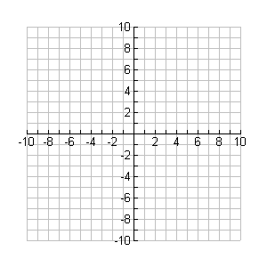

**y**

**x**

|  |  |
| --- | --- |
| x | y |
| 0 |  |
| 1 |  |
| 4 |  |
| 9 |  |

b) Use transformations to graph the following functions:

i) $y=-3\sqrt{x}+4$ ii) $y=\sqrt{2x-8}$

k = k =

d = d =

a = a =



**y**

**x**

c = c =



**y**

**x**

**Example 3**

a) Complete the table of values then graph the function .



**y**

**x**

|  |  |
| --- | --- |
| x | $$y=2^{x}$$ |
| -2 |  |
| -1 |  |
| 0 |  |
| 1 |  |
| 2 |  |

-`

b) Use transformations to graph the following functions:

Note: For the parent function $y = 2^{x},$ the transformation constants are

found in the following locations: $y = a{(2)}^{[k(x - d)] }+ c$

**i) $y=-2(2)^{x-2}+5$ ii) $y=2^{-\frac{1}{2}x-2}$**

k = k =

d = d =

a = a =



**y**

**x**



**y**

**x**

c = c =