Sinusoidal Functions Worksheet

Practice:

- For each sinusoidal function below, state the amplitude, period, phase, vertical displacement domain and range without graphing:

a) $y=-3\sin\left(2θ-60°\right)-1$ b) $y=2\cos\left(-3θ-135°\right)+5$

- Graph the following sinusoidal functions. State the domain and range.

a) $y=\cos{(2θ-120°)}-3$ b) $y=-3\sin\left(θ+30°\right)-1$
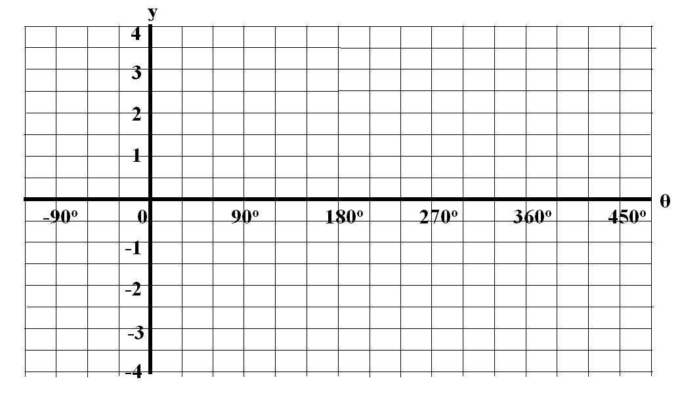

Domain: Domain:
Range: Range:

c) $y=-2sin{(3θ+180°)}+1$ d) $y=1.5\sin\left(-θ+90°\right)-1$

Domain: Domain:
Range: Range:
- Create another sinusoidal equation that would represent the graph obtained in question 2d). Answers will vary.

- A mass hangs from a spring. The mass is pulled down and released at
t = 0 seconds. It is allowed to oscillate freely up and down at a frequency of 5 Hz (5 cycles every second). At its lowest point, the mass is 15 cm from the ground. At its maximum height the mass is 55 cm from the ground. How high off the ground is the mass 2.7 seconds after being released?

- The changes to the population of Jawas on Tatooine can be modeled by a sinusoidal function. Initially, the population of Jawas in 1977 was at a minimum of 12000. In 1984, the population peaked at 20000 for the first time. The population would reach its minimum again in 1991. What was the population of Jawas in 1988?

- The depth of water off the coast of Sinusoiland changes periodically due to the lunar tides. The minimum depth of the water is 2 m and the maximum depth is 8 m. At 1:00 pm, the water depth is at equilibrium (5 m) and moving towards its maximum. If one full cycle for the tides takes 12.5 hours, what was the depth of water at 6 pm. Assume that the period behaviour can be modelled by a sinusoidal.

