Homework: pg 352 # 1 - 9, 11*

Modeling Periodic Behaviour

Periodic behaviour describes a function that repeats.
Some examples of periodic behaviour are:

- The outside temperature as a function of time in years.
- The amount of daylight on a daily basis.
- The electrical activity around the heart as viewed on an electrocardiogram (ECG).
- The population of tent caterpillars; pattern repeats every 10 years.
- The voltage of an AC (alternating current) electric circuit.
- Financial stability in the market; recessions occur about once every 10 years; 1981, 1991, 2001, 2009

Periodic events are often discussed using the following key terms:

- Cycle – one repetition in a repeating process.
- Period (T) – The change in the independent variable (typically time in seconds) corresponding to one cycle.
- Frequency (f) – the number of cycles that occur per unit of the independent variable. If the independent variable is time measured in seconds then the frequency is measured in s⁻¹ or Hz (Hertz).
- Line of Equilibrium (simply called the “axis” in the textbook) – a horizontal line that is positioned halfway up from the bottom of the graph to the top.
- Amplitude – Half of the graph’s range or the vertical distance from the line of equilibrium to the top of the graph.

Example 1

If the maximum temperature in Guelph is 28ºC and the minimum temperature is
–12ºC each year then calculate the amplitude and the line of equilibrium:

Amplitude $= \frac{maximum-minimum}{2}=$

Line of Equilibrium $= \frac{maximum+minimum}{2}=$

Period and frequency are related by the equations:

or

Example 2

Determine if each graph describes periodic behaviour. If the graph is periodic, label one cycle, determine the amplitude, period, frequency and equation of the line of equilibrium.
Amplitude =

Period =

Frequency =

Equation of the line of equilibrium
a) Amount of Daylight in Balmaceda, Chile

Amplitude =

Period =

Frequency =

Eqn of the Axis:

b) A Normal ECG
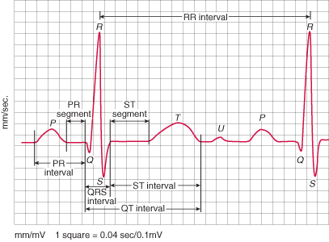
Amplitude =

Period =

Frequency =

Equation of the line of equilibrium
0 v
c) Radius of Atom
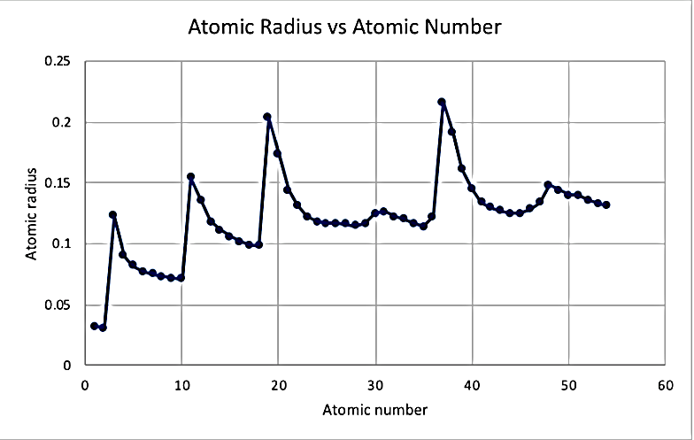
Amplitude =

Period =

Frequency =

Equation of the line of equilibrium

