**Homework: pg 160 # 1, 4, 6, 10, 11, 12, 13ac**

**The Inverse of a Quadratic Function**

**Activity**

Graph the function $y=x^{2}+1$ and its inverse on the grid below.

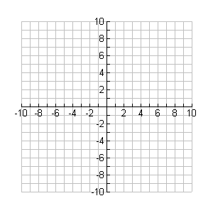

**y**

**x**

From the above graphs, we see that the inverse of $y=x^{2}+1$ can be determined by reflecting the entire graph about the _________ line.

We also note that the inverse of $y=x^{2}+1$ is not a function since it would fail the ___________ ______ _______.

**Example 1**

For each function below, determine the domain and range. Then, determine the inverse of the function state its domain and range. Compare.

1. $y={(x+2)}^{2}-5$ b) $y=\sqrt{x-1}+3$

Domain: Domain:

Range: Range:

Inverse Inverse

**Example 2**

The profit of a company can be modeled using the following equation:

$$P\left(x\right)=-0.001{\left(x-150,000\right)}^{2}+10,000,000$$

where

* P(x) is the total profit (in $)
* x is the amount of money invested in advertising (in $)

1. Determine the inverse for this function. ie; isolate the equation for the variable x.

***Note: that when finding the inverse of an equation that represents a real world application, we do not swap variables.***

1. How much should be spent on advertising to earn $5,000,000 in profit?