**The Inverse of a Function**

The inverse of a function can be determined from a table of values, from an equation algebraically, or using a graph.

**Table of Values**

The inverse of a function can be determined from a table of values by swapping x and y variables.

Ex:

Determine the inverse of each relationship represented below.

|  |  |
| --- | --- |
| x | y |
| 1 | 8  inverse |
| 3 | 5 |
| 5 | 2 |
| 7 | -1 |

|  |  |
| --- | --- |
| x | y |
| 0 | 18 |
| 1 | 22 |
| 2 | 26 |
| 3 | 30 |

|  |  |
| --- | --- |
| x | y |
|  |  |
|  |  |
|  |  |
|  |  |

|  |  |
| --- | --- |
| x | y |
|  |  |
|  |  |
|  |  |
|  |  |

a) b)

inverse

**Equations**

The inverse of a function can be determined by swapping x and y variables then isolating for y.

Ex:

Determine the inverse of each relationship below.

a) $f(x) = 2x + 5$ b) $y =\frac{2}{x-5}$ c) $f\left(x\right)=x^{2}+3$

Note: The symbol $f^{-1}\left(x\right)$ represents the inverse of the function $f(x)$ when its’ inverse is also a function. Therefore, the symbol $f^{-1}\left(x\right)$ cannot be used in question c).

Inverses Graphically

Graph each function below on the left and its inverse on the right.

State the domain and range for each.

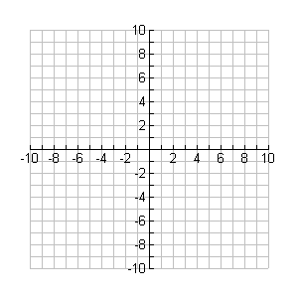

**y**

**x**



**y**

**x**

a) 



**y**

**x**



**y**

**x**

b) 

Some Properties of Inverses (as shown from the graphs above):

1. The inverse is obtained by reflecting the graph about the y = x line; or by interchanging the ‘x’ and ‘y’ coordinates of each point.
2. The inverse of a function is not always a function; the inverse in a) is a function while the inverse in b) is not.
3. The domain of the inverse can be determined by examining the range of the original function.
4. The range of the inverse can be determined by examining the domain of the original function.

Homework: pg 46 # 1, 3, 4, 5, 6, 10ace, 16, 17