**Quiz**

1. Graph the function $f\left(x\right)=-\frac{3}{2x-2}+4$ and state the domain and range.

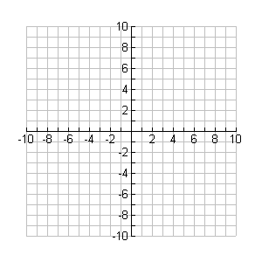

**y**

**x**

Domain: Range:

1. Evaluate the following:
$$f\left(x\right)=3x-4$$

$$g\left(x\right)=x^{2}-2x+1$$

2. $f^{-1}(8)$ b) $f(g\left(x\right))$