Introduction to the Sine and Cosine Curve

The Sine Curve

- Complete the table of values and graph the function y = sinθ.
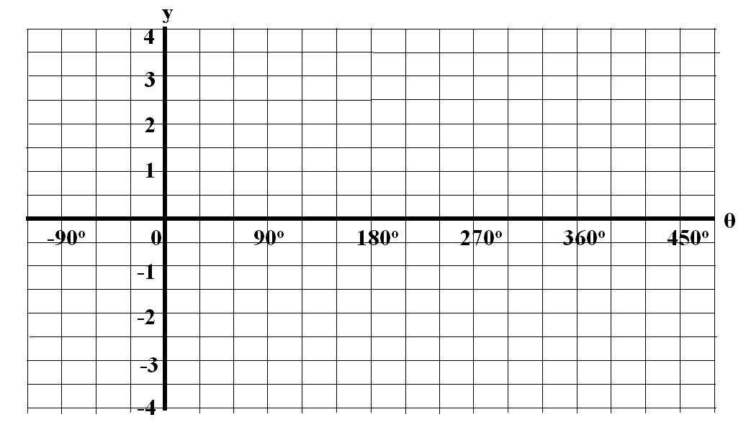
θ | y = sinθ
0º
30º
60º
90º
120º
150º
180º
210º
240º
270º
300º
330º
360º

The Cosine Curve

- Complete the table of values and graph the function y = cosθ.
θ | y = cosθ
0º
30º
60º
90º
120º
150º
180º
210º
240º
270º
300º
330º
360º

Follow-Up

- What do both the sine curve and cosine curve have in common?

- What is different about the sine curve and the cosine curve?

Homework: Complete graphs below + Pg. 363 #2, 7, 9, 10, (11ab)

For each equation, complete the table of values and graph the function.

a) y = sinθ + 2
θ | y = sinθ + 2
0º
30º
60º
90º
120º
150º
180º
210º
240º
270º
300º
330º
360º

b) y = sin(θ - 60º)
θ | y = sin(θ - 60º)
0º
30º
60º
90º
120º
150º
180º
210º
240º
270º
300º
330º
360º

c) y = 2sinθ
θ | y = 2sinθ
0º
30º
60º
90º
120º
150º
180º
210º
240º
270º
300º
330º
360º

d) y = sin3θ
θ | y = sin3θ
0º
30º
60º
90º
120º
150º
180º
210º
240º
270º
300º
330º
360º

e) y = 2sinθ -1
θ | y = 2sinθ -1
0º
30º
60º
90º
120º
150º
180º
210º
240º
270º
300º
330º
360º

90º
0
180º
270º
360º
450º
-90º
1
2
3
4
-1
-2
-3
-4
θ
y

