Homework: pg 198 #1c, 2, 3, 4ab, 5, 8, 10, (11), 13

**Intersection of Linear and Quadratic Functions**

**Warm-up**

Determine the point of intersection of the two lines $y=-2x+10$ and $y=-x+2$ using a variety of techniques.

Elimination Substitution Graphing

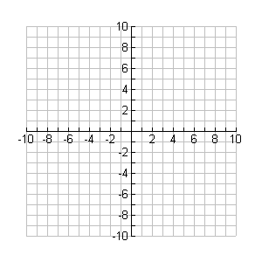

**y**

**x**

**Example 1**

Determine the point(s) of intersection of the line $y = 2x-2$ and the parabola $y=2x^{2}-8x+10$.



**y**

**x**

**Example 2**

Determine the point(s) of intersection of the line $y = 4x-14$ and the parabola $y=-2x^{2}+12x-22$.



**y**

**x**

**Example 3**

Determine the point(s) of intersection of the parabola $y=x^{2}+4x+5$ and the line $y = x-2$.



**y**

**x**