**MCR3U – Exponential Functions – Review Worksheet**

1. Expand and simplify each expression

a) ${\left(-3xy\right)}^{4}$ b) $\frac{6x^{3}y^{6}}{3x^{2}yz^{3}}$ c) ${\left(\frac{y}{3}\right)}^{-4}$

d) e) f) g) h) i)

2. Evaluate the following powers with rational exponents.

a) b) c) d)

3. Solve each equation for x.

a) b) c) d)

4. Graph the following exponential functions then state the domain and range.

a) b)

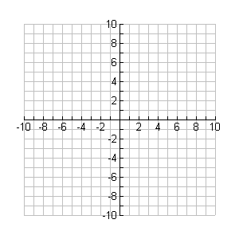

**y**

**x**



**y**

**x**

5. Determine if each relationship is either linear, quadratic or none of these.

|  |  |
| --- | --- |
| x | y |
| 3 | 6 |
| 5 | 22 |
| 7 | 46 |
| 9 | 78 |
| 11 | 118 |

|  |  |
| --- | --- |
| x | y |
| 0 | 0 |
| 1 | 2 |
| 2 | 8 |
| 3 | 26 |
| 4 | 80 |

|  |  |
| --- | --- |
| x | y |
| 4 | 15 |
| 2 | 20 |
| 0 | 25 |
| -2 | 30 |
| -4 | 35 |

a) b) c)

6. Eileen purchases a Landspeeder for $48500 in 2020. This vehicle

depreciates at a rate of 8%/year.

a) Create an equation that represents the value of the car, V in dollars, as

it depreciates with time, t in years.

b) How much will the Landspeeder be worth in the year 2030?

7. During the early spring, the thickness of ice on Guelph Lake drops by a factor of one half every 10 days. Currently, the ice has a thickness of 30 cm.

a) Create an equation to represent the thickness of ice on Guelph Lake,

D in cm, as it relates to the elapsed time, t in days.

b) What will be the thickness of ice on Guelph Lake 25 days from now?

8. The price of a loaf of bread increases exponentially each year after 2020 by

about 2.3%. A loaf of bread currently retails for $3.49.

a) Create an equation that represents the price of one loaf of bread, P in

dollars, as a function of elapsed time, t in years.

b) How much will a loaf of bread cost in 2040?

c) How much did a loaf of bread cost in 1945 when World War II

ended?

9. A frozen Sasquatch corpse is found in the Northern Canadian regions. A

sample of the Sasquatch is found to have 200 carbon-14 atoms. The

decaying half-life of carbon-14 is known to be approximately 5700 years. If

the Sasquatch sample, based on its mass, was expected to have originally

had 320 carbon-14 atoms, how old is this furry Sasquatch?