Homework: pg 35 # 1ab, 2, 3, 4, 5, 7, 9abde, 11ac, 16a

Domain and Range

Number Sets

In mathematics, the following sets (groups) of numbers are defined.

* Natural Numbers (N) = {1, 2, 3, 4, 5, …}
* Whole Numbers (W) = {0, 1, 2, 3, 4, 5…}
* Integers (Z) = {…, -3, -2, -1, 0, 1, 2, 3, …}
* Rational Numbers (Q) = { such that n and m are

integers and  }

* Irrational Number (I) = {numbers that aren’t rational such as π and }
* Real Numbers (**3-less07**) = {N, W, Z, Q, I}

These sets can be displayed in the following Venn Diagram:

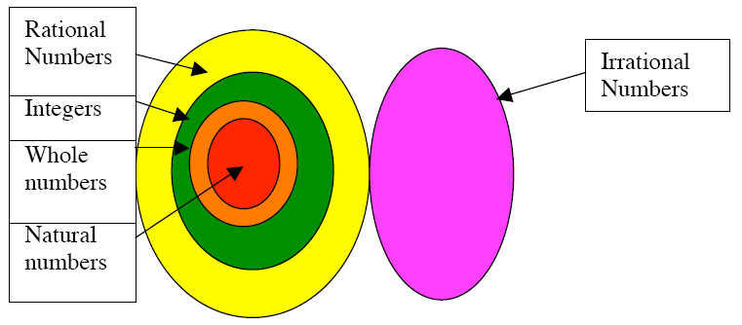

# Inequality Symbols

Recall from previous teachings that the crocodile (<) always eats the larger quantity.

|  |  |
| --- | --- |
| Symbol | Definition |
|  | greater than |
|  | greater than or equal to |
|  | less than |
|  | less than or equal to |
| = | equal to |
|  | not equal to |

Example 1

Define the selected values of ‘x’ on each number line using number sets and inequalities.

a) 

b) 

c) 

d) 

Domain and Range

Domain – the set of independent values represented by a relationship.

Ex; Domain = {x  3-less07| x  0}

This would read “x belongs to the set of real numbers such that x is greater than or equal to zero”.

Range – the set of dependent values represented by a relationship.

Ex; Range = { y  Z | y  5}

This would read “y belongs to the set of integers such that y is greater than or equal to 5.

Example 2

Graph each equation below then determine the domain and range.

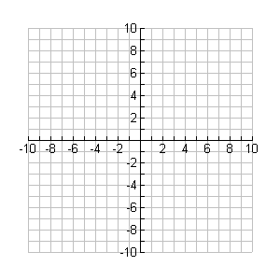

**y**

**x**



**y**

**x**

a)  b) 



**y**

**x**



**y**

**x**

c)  d) 

|  |  |
| --- | --- |
| x | y |
| -2 |  |
| -1 |  |
| 0 |  |
| 1 |  |
| 2 |  |

|  |  |
| --- | --- |
| x | y |
| 0 |  |
| 1 |  |
| 4 |  |
| 9 |  |



**y**

**x**



**y**

**x**

e)  f) 

|  |  |
| --- | --- |
| x | y |
| -2 |  |
| -1 |  |
| 0 |  |
| 1 |  |
| 2 |  |

|  |  |
| --- | --- |
| x | y |
| 0 |  |
| 1 |  |
| 4 |  |
| 9 |  |