Applications of Sinusoidal Functions

The equation of a sinusoidal function can be determined from its graph:

1. Draw a box around one cycle of a sinusoidal.
2. The value for ‘k’ can be determined from the period (one cycle) of the sinusoidal of measured from peak to peak. Then use the equation 
3. The value ‘c’ is the location of the line of equilibrium or use 
4. The phase shift ‘d’ is the horizontal distance to the left of the box.
5. The value of ‘a’, the vertical expansion/compression, is closely related to the amplitude since the amplitude $=|a|$; use the amplitude for a then assign a negative if the graph is a reflected sine or cosine curve about the independent axis.

**Activity**

Create a simple basic sketch of the following sinusoidal functions:

$y=\cos{θ}$ $y=-cos{θ}$ $y=\sin{θ}$ $y=-\sin{θ}$

y

y

y

y

θ

θ

θ

θ

# Example 1

Determine an equation for each sinusoidal graph below:

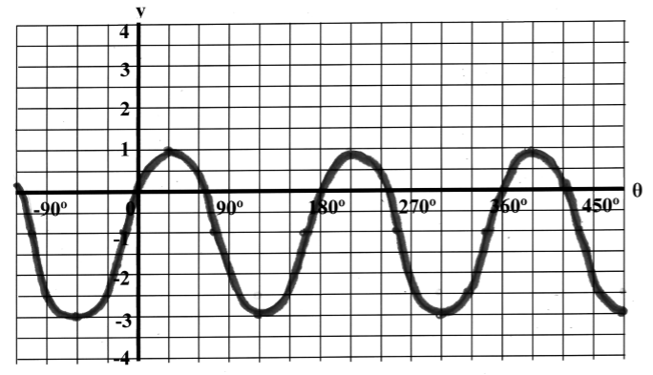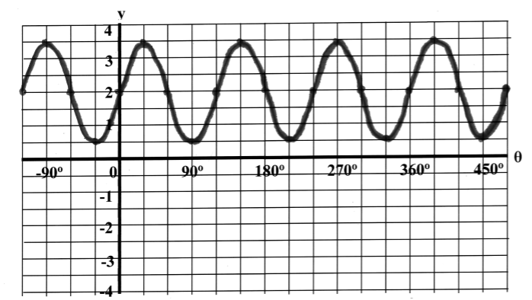a) b)

Example 2

The first Ferris wheel built in 1893 had a diameter of 80 m. The base of the wheel was 5 m above the ground. It took 20 minutes to do 2 full revolutions. If Milton boarded the bottom of the wheel at 9:07, how high from the ground would he be at 9:20?

[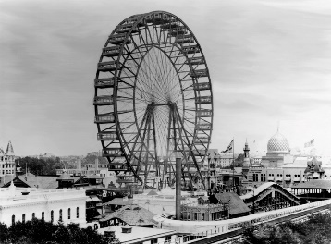](http://upload.wikimedia.org/wikipedia/commons/d/de/Ferris-wheel.jpg)

**Example 3**

The top of a building designed by Fractals Incorporated sways East (10 m) then West

(-10 m) of its stable equilibrium position. One full swing from equilibrium to the East, to the West then back to equilibrium takes 8 seconds. At t = 1s, the building is at equilibrium and about to swing East. What is the displacement at the top of the building at 4 seconds?

Homework: pg398 # 1, 2, 4, 5, 11, 13ab